Meeting Notice and Agenda
Town Board of Trustees
Regular meeting
January 10, 2017 - 6:00 pm
Mounds Community Building
15 W 14th St, Mounds, OK 74047

1. Call to Order Time __________
2. Roll Call
Veale ___ Jackson, D ___ Reynolds ___ Ingham ___ Jackson, R ___
3. Invocation
4. Pledge of Allegiance
5. Consent Agenda (A-I)
All matters listed under the “Consent “are considered by the Town Board to be routine and will be enacted by one motion. Any Trustee may, however, remove an item from the Consent Agenda by request.
A. Approval of the minutes of the December 12, 2016 Regular Board Meeting
B. Approval of the Library report.
C. Approval of the Police report
D. Approval of the Fire report
E. Approval of the Financial report.
F. Approval of the Budget report.
G. Approval of the Court report.
H. Approval of the Purchase Orders for General Government, Fire Department and Court Fund.
I. Approval of the Purchase Orders for Streets & Alleys and Parks Depts.
Motion ___________________________ Second __________________
Roll call: Veale ___ Jackson, D ___ Reynolds ___ Ingham ___ Jackson, R ___
6. Building Inspector Report
7. Incog Reap Application for Economic/Community Development
Discuss, consider and take possible action on approving and submitting application to INCOG for this grant.
Motion ___________________________ Second __________________
Roll call: Veale ___ Jackson, D ___ Reynolds ___ Ingham ___ Jackson, R ___
8. Resolution 20170110A
Discuss, consider and take possible action on resolution 20170110A.
Motion ___________________________ Second __________________
Roll call: Veale ___ Jackson, D ___ Reynolds ___ Ingham ___ Jackson, R ___
9. INCOG REAP Application for Transportation
Discuss, consider and take possible action on approving and submitting application to INCOG for this grant.
Motion ___________________________ Second __________________
Roll call: Veale ___ Jackson, D ___ Reynolds ___ Ingham ___ Jackson, R ___
10. Resolution 20170110B
Discuss, consider and take possible action on Resolution 20170110B.
Motion ___________________________ Second __________________
Roll call: Veale ___ Jackson, D ___ Reynolds ___ Ingham ___ Jackson, R ___
11. American Municipal Services
Discuss, consider and take possible action on American Municipal Services.
Motion ___________________________ Second __________________
Roll call: Veale ___ Jackson, D ___ Reynolds ___ Ingham ___ Jackson, R ___
12. Creek Nation Lighthorse Police
Discuss, consider and take possible action on Creek Nation Lighthorse Police.
Motion ___________________________ Second __________________
Roll call: Veale ___ Jackson, D ___ Reynolds ___ Ingham ___ Jackson, R ___
13. Reserve Officer
Discuss, consider and take possible action on hiring a reserve officer on temporary assignment while Officer Holiday is at training.
Motion ___________________________ Second __________________
Roll call: Veale ___ Jackson, D ___ Reynolds ___ Ingham ___ Jackson, R ___
16. City Hall and Police Station
Discuss, consider and take possible action on construction of a new City Hall and Police Station and/or relocation of City Hall and Police Station to new location.
17. Budget Process Workshop
Discuss, consider and take possible action on sending Rob Ford to a Budget Process Workshop.
Motion ___________________________ Second __________________
Roll call: Veale ___ Jackson, D ___ Reynolds ___ Ingham ___ Jackson, R ___
18. Vyve Broadband
Discuss, consider and take possible action on rescinding cable franchise Vyve Broadband.
Motion ___________________________ Second __________________
Roll call: Veale ___ Jackson, D ___ Reynolds ___ Ingham ___ Jackson, R ___
19. Executive Session
The Board will consider retiring into Executive Session for the purpose of discussion related to the employment, hiring, appointment, promotion, demotion, disciplining or resignation of individual salaried public officer or employees (Town Administrator), in accordance with O.S. Title 25, Section 307(B)(1):
Motion _____________________ Second _______________________
Roll call: Veale ___ Jackson, D ___ Reynolds ___ Ingham ___ Jackson, R ___
- Council will consider returning to the Regular Meeting following the Executive Session. Time _______
- Board will consider and take any action deemed appropriate, as a result of the Executive Session.

Motion _____________________ Second _______________________
20. Adjournment Time _______________
This agenda was filed in the office of the Town Clerk and posted at _6__ pm on January 9, 2017 at the Mounds Municipal Building located at 1319 Commercial Ave, Mounds, OK 74047 and the Mounds Community Building located at 15 W 14th St, in Mounds, OK 74047, by Town Clerk Kristin Haddock.
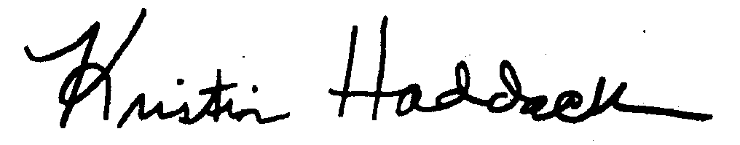
_
Kristin Haddock Town Clerk

