Meeting Notice and Agenda
Planning Commission
October 24, 2017 7:00pm
Mounds Community Building
15 W 14th St, Mounds, OK 74047

- Call to Order Time _______

- Roll Call
Ingham ___ Harmon ___Long ___

- Past Minutes
Discuss, consider and take possible action on previous minutes from February 1 & 23, March 23, June 7 & 26, and August 16, 2017
Motion ____________________ Second ___________________
Roll call: Ingham ___ Harmon ___ Long ___

- Mounds Fence Line
Discuss, consider and take possible action regarding the extension of the Town of Mounds fence line.
Motion ____________________ Second ___________________
Roll call: Ingham ___ Harmon ___ Long ___

- Special Exception
Discuss, consider and take possible action regarding Matt Ingham’s Application for Special Exception to build a small shed in his backyard.

Motion ____________________ Second ___________________
Roll call: Ingham ___ Harmon ___ Long ___

- Annexation
Discuss, consider and take possible action on annexing 8750 Gunner Rd into Town of Mounds City Limits
Motion ____________________ Second ___________________
Roll call: Ingham ___ Harmon ___ Long ___

- Adjournment Time _____________

This agenda was filed in the office of the Town Clerk and posted at _6__ pm on October 20, 2017 at the Mounds Municipal Building located at 1319 Commercial Ave, Mounds, OK 74047 and the Mounds Community Building located at 15 W 14th St, in Mounds, OK 74047, by Town Clerk Kristin Haddock.

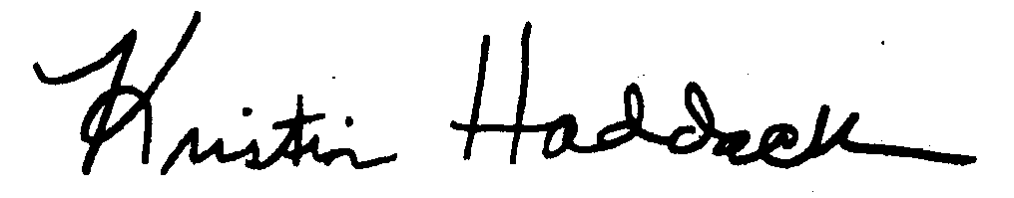
______________________________
Kristin Haddock Town Clerk

