Meeting Notice and Agenda
Town Board of Trustees
Regular Meeting
September 19, 2023 – 6:30 pm
Mounds Community Building
15 W 14th Street, Mounds OK 74047

- Call to Order

2. Roll Call

3. Consent Agenda (A-K)
All matters listed under “Consent” are considered by the Town Board to be routine and will be enacted by one motion. Any Trustee, however, can remove an item from the Consent Agenda by request.

A. Approval of the Minutes for the August 15, 2023, regular meeting.
B. Approval of the Library report
C. Approval of the Police report
D. Approval of the Fire report
E. Approval of the Financial report
F. Approval of the Budget report
G. Approval of the Court report
H. Approval of Purchase Orders for Streets & Alleys and Parks Departments
I. Building Inspector Report
J. Approval of the Purchase Orders for General Government, Streets & Alleys, and
Court Fund

4. Zoning Commercial Ave
Discuss, consider, and take possible action on zoning Commercial Ave from 8th street to 16th street for retail only.

5. REAP Grant
Discuss, consider, and take possible action on selecting project(s) for the INCOG REAP grant(s)
6. Resolution 20220919
Discuss, consider, and take possible action on Resolution 20220913, authorizing application for
the INCOG REAP Grant
7. Phone System
Discuss, consider, and take possible action on purchasing a new phone system.

8. Stop Sign
Discuss, consider, and take possible action on installing a stop sign at 17th and Maxwell.

9. Specific Use
Discuss, consider, and take possible action on 1115 Commercial Specific Use Application.

10. Digital Sign
Discuss, consider, and take possible action on a digital sign.

11. Signature Stamp
Discuss, consider, and take possible action on having a stamped signature for all bank accounts.

12. CCRWD 7
Discuss, consider, and take possible action on CCRWD 7 contract.

13. Property Owners
Discuss, consider, and take possible action on notifying property owners to clean up trash, clutter, and trees growing through and around homes within 30 days or face a fine.

14. Budget Amendments
Discuss, consider, and take possible action on 22-23 Budget Amendments (see list).

15. PTO Fall Carnival
Discuss, consider, and take possible action on PTO Carnival 9/30/23.

16. Movie Night
Discuss, consider, and take possible action on Movie Night in the Park, Oct. 20, 2023.

17. Executive Session
The Trustees will consider retiring into Executive Session for the purpose of discussion of
- Review of individual candidates for the purpose of employment, hiring, or appointment of individual salaried city employee in accordance with 25 O.S. Section 307(B)(1); and
- Discussion concerning the purchase or appraisal of real property pursuant to 25 O.S. 307(B)(3).
- Trustees will consider and take any action deemed appropriate related to the above items.

18. Adjournment

This Agenda was filed in the office of the Town Clerk and posted at 6 PM on September 18, 2023, at the Mounds Municipal Building located at 1319 Commercial Avenue, Mounds, OK 74047 and the Mounds Community Building located at 15 W 14th Street in Mounds, OK 74047, by Town Clerk Kristin Haddock.

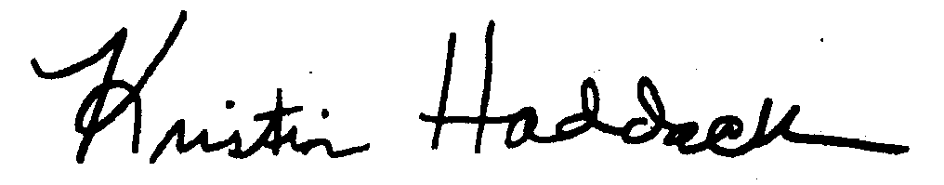
Kristin Haddock, Town Clerk

