Meeting Notice and Agenda
Town Board of Trustees
Regular Meeting
April 12, 2022 – 6:00 pm
Mounds Community Building
15 W 14th Street, Mounds OK 74047

1. Call to Order
2. Roll Call
3. Consent Agenda (A-K)
All matters listed under “Consent” are considered by the Town Board to be routine and will be enacted by one motion. Any Trustee, however, can remove an item from the Consent Agenda by request.

A. Approval of the Minutes for the March 8, 2022, Regular Board Meeting
B. Approval of the Library report
C. Approval of the Police report
D. Approval of the Fire report
E. Approval of the Financial report
F. Approval of the Budget report
G. Approval of the Court report
I. Approval of Purchase Orders for Streets & Alleys and Parks Departments
J. Building Inspector Report
K. Mayor’s Report
L. Approval of the Purchase Orders for General Government, Fire Department, and
Court Fund
M. Discuss, consider, and take possible action on bad debt write-off in the amount of
$26.00 at 1212 Commercial due to forfeited tap.
N. Discuss, consider, and take possible action on bad debt write-off in the amount of
$62.16 for the fire department 18654 S 80th W Avenue.
O. Approval of amending the police department gasoline budget by an additional
$4,000, amending the PWA gasoline budget by an additional $1,000, and
amending the fire department gasoline budget by an additional $1,500.

4. CDBG ITEMS WITH INCOG
a. Citizen Participation Plan
Discuss, consider, and take possible action on adopting the Citizen Participation Plan

b. 2022 CDBG Project
Discuss, consider, and take possible action on selection of the 2022 CDBG Project
c. CDBG Resolution
Discuss, consider, and take possible action on adopting of the CDBG Resolution requesting assistance from the Oklahoma Department of Commerce
d. Authorization for Mayor to Sign all CDBG Documents
Discuss, consider, and take possible action on authorizing the mayor to execute application documents.
5. Fireworks
Discuss, consider, and take possible action on having fireworks June 25 in conjunction with Fish Fry
6. Creek County ARPA
Discuss, consider, and take possible action on update on Creek County ARPA

7. City Hall
Discuss, consider, and take possible action on City Hall Project, as follows:

- Review of design and bid documents from Native Fusion.
- Motion to authorize Native Fusion to proceed with bidding of the City Hall project.
- Motion to authorize Mayor to sign financing documents with American Heritage Bank, including loan or lease documents.

8. Building Inspector
Discuss, consider, and take possible action on building inspector

9. Town Credit Cards
Discuss, consider, and take possible action on Town credit cards

10. Fair Housing Month
Discuss, consider, and take possible action on declaring April as Fair Housing Month

11. Juvenile Justice Budget Amendment
Discuss, consider, and take possible action decreasing Fines and Forfeitures revenue from by $1090 and increasing Vista Grant cost share by $280.
12. 2020-2021 Audit Report
Discuss, consider, and take possible action to accept audit as presented by auditor.

13. Executive Session
The Trustees will consider retiring into Executive Session for the purpose of discussion for item A. related to the employment, hiring, appointment, promotion, demotion of individual salaried (Hiring of a police officer) making permanent for benefit purposes in accordance with O.S. Title 25, Section 307(B)(1).

- Trustees will consider and take any action deemed appropriate to the hiring of a police officer

14. Adjournment
This Agenda was filed in the office of the Town Clerk and posted at 6 PM on April 11, 2022, at the Mounds Municipal Building located at 1319 Commercial Avenue, Mounds, OK 74047 and the Mounds Community Building located at 15 W 14th Street in Mounds, OK 74047, by Town Clerk Kristin Haddock.
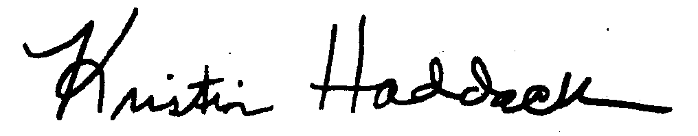
Kristin Haddock, Town Clerk

