Meeting Notice and Agenda
Town Board of Trustees
Regular Meeting
April 13, 2021 - 6:00 pm
Mounds Community Building
15 W 14th St, Mounds, OK 74047
1. Call to Order
2. Roll Call
3. Consent Agenda (A-I)
All matters listed under the “Consent “are considered by the Town Trustees to be routine and will be enacted by one motion. Any Trustee, however, can remove an item from the Consent Agenda by request.
A. Approval of the minutes of the March 9, 2021 Regular Board Meeting
B. Approval of the Library report.
C. Approval of the Police report
D. Approval of the Fire report
E. Approval of the Financial report.
F. Approval of the Budget report.
G. Approval of the Court report.
H. Approval of the Purchase Orders for General Government, Fire Department and Court Fund.
I. Approval of the Purchase Orders for Streets & Alleys and Parks Depts.
4. Building Inspector Report
Discuss, consider, and take possible action on Building Inspector
5. 2021-2022 Budget
Discuss, consider and take possible action on 2021-2022 Budget Calendar
6. PD Equipment
Discuss, consider and take possible action on PD Equipment Budget Amendment

7. Capital Outlay
Discuss, consider, and take possible action on correcting General Fund Capital Outlay Budget Amendment
8. Allocate Funding

Discuss, consider, and take possible action on allocating funding for new city hall, police, and fire department buildings

9. Town Sponsored Events
Discuss, consider, and take possible action on Town sponsored events
10. Reorganizing Board of Trustees
Discuss, consider, and take possible action on reorganizing Board of Trustees and assign duties.
11. Police Unit
Discuss, consider and take possible action on Police unit
12. Part-Time Temp Pay
Discuss, consider and take possible action on obtaining a part-time temp pay officer
13. Adjournment

This agenda was filed in the office of the Town Clerk and posted at _6__ pm on April 12, 2021, at the Mounds Municipal Building located at 1319 Commercial Ave, Mounds, OK 74047 and the Mounds Community Building located at 15 W 14th St, in Mounds, OK 74047, by Town Clerk Kristin Haddock.

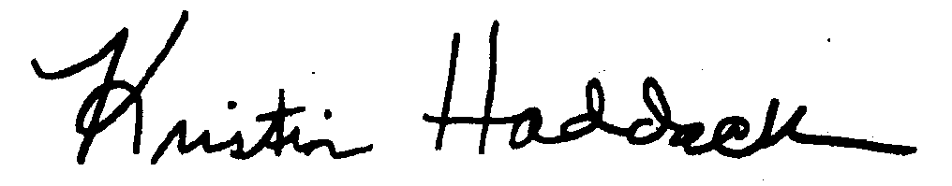
_______________________
Kristin Haddock Town Clerk

