Meeting Notice and Agenda
Town Board of Trustees
Regular Meeting
August 14, 2018 - 6:00 pm
Mounds Community Building
15 W 14th St, Mounds, OK 74047

1. Call to Order Time __________
2.Roll Call
Jackson, R ___ Reynolds ___ Ingham ___ Jackson, D ___ Ford ___
3. Invocation
4. Pledge of Allegiance
5. Consent Agenda (A-I)
All matters listed under the “Consent “are considered by the Town Board to be routine and will be enacted by one motion. Any Trustee, however, can remove an item from the Consent Agenda by request.
A. Approval of the minutes of the July 10, 2018 Regular Board Meeting B. Approval of the Library report.
C. Approval of the Police report
D. Approval of the Fire report
E. Approval of the Financial report.
F. Approval of the Budget report.
G. Approval of the Court report.
H. Approval of the Purchase Orders for General Government, Fire Department and Court Fund.
I. Approval of the Purchase Orders for Streets & Alleys and Parks Depts.

Motion ___________________________ Second __________________
Roll call: Jackson, R ___ Reynolds ___ Ingham ___ Jackson, D ___ Ford ___
6. Public Hearing Open time ____
Discuss, consider and take possible action on public hearing of abatement for property located at 1310 Dorman Ave.
Motion ___________________________ Second __________________
Roll call: Jackson, R ___ Reynolds ___ Ingham ___ Jackson, D ___ Ford ___
7. Building Inspector Report

8. Library Edge Grant
Discuss, consider and take possible action on the Library’s Edge Grant
Motion ___________________________ Second __________________
Roll call: Jackson, R ___ Reynolds ___ Ingham ___ Jackson, D ___ Ford ___
9. Jacob Mosquito
Discuss, consider and take possible action on giving access to Jacob Mosquito to park his vehicle at the park adjacent to Maxwell.
Motion ___________________________ Second __________________
Roll call: Jackson, R ___ Reynolds ___ Ingham ___ Jackson, D ___ Ford ___
10. Trash Bids
Discuss, consider and take possible action on Trash Bids
Motion ___________________________ Second __________________
Roll call: Jackson, R ___ Reynolds ___ Ingham ___ Jackson, D ___ Ford ___
11. Checks and Purchase Orders
Discuss, consider and take possible action on approval of checks and purchase orders via email
Motion ___________________________ Second __________________
Roll call: Jackson, R ___ Reynolds ___ Ingham ___ Jackson, D ___ Ford ___
12. Adjournment Time _______________
This agenda was filed in the office of the Town Clerk and posted at _6__ pm on August 13, 2018 at the Mounds Municipal Building located at 1319 Commercial Ave, Mounds, OK 74047 and the Mounds Community Building located at 15 W 14th St, in Mounds, OK 74047, by Town Clerk Kristin Haddock.
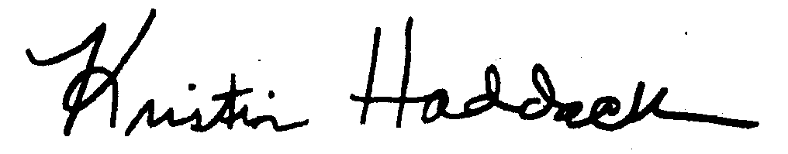
______________________________________
Kristin Haddock Town Clerk

