Meeting Notice and Agenda
Town Board of Trustees
Regular Meeting
August 15, 2023 – 6:30 pm
Mounds Community Building
15 W 14th Street, Mounds OK 74047

1. Call to Order

2. Roll Call

3. Consent Agenda (A-K)
All matters listed under “Consent” are considered by the Town Board to be routine and will be enacted by one motion. Any Trustee, however, can remove an item from the Consent Agenda by request.
A. Approval of the Minutes for the July 18, 2023, regular meeting.
B. Approval of the Library report
C. Approval of the Police report
D. Approval of the Fire report
E. Approval of the Financial report
F. Approval of the Budget report
G. Approval of the Court report
H. Approval of Purchase Orders for Streets & Alleys and Parks Departments
I. Building Inspector Report
J. Approval of the Purchase Orders for General Government, Streets & Alleys, and Court Fund

4. Event Committee
Discuss, consider, and take possible action on Event Committees dates.

5. Cemetery
Discuss, consider, and take possible action on Christine Adams wanting a special exception for a bench at the cemetery.

6. New Officers (Fire Department)
Discuss, consider, and take possible action on swearing in new Officers for the Fire Department.

7. Cindy Groover
Discuss, consider, and take possible action on discussion about Go-Bob.

8. CDBG & REAP
Discuss, consider, and take possible action on the 23-24 CDBG and REAP projects.

9. Adjournment

This Agenda was filed in the office of the Town Clerk and posted at 6 PM on August 14, 2023, at the Mounds Municipal Building located at 1319 Commercial Avenue, Mounds, OK 74047 and the Mounds Community Building located at 15 W 14th Street in Mounds, OK 74047, by Town Clerk Kristin Haddock.

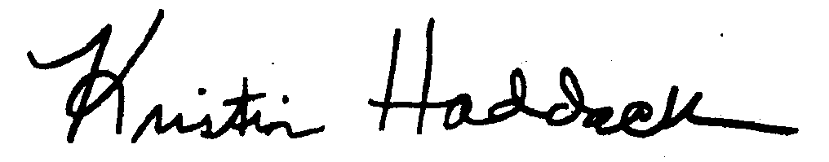
Kristin Haddock, Town Clerk

