Meeting Notice and Agenda
Town Board of Trustees
Regular Meeting
August 9, 2022 – 6:00 pm
Mounds Community Building
15 W 14th Street, Mounds OK 74047

1. Call to Order Time: _____________

2. Roll Call

3. Consent Agenda (A-K)
All matters listed under “Consent” are considered by the Town Board to be routine and will be enacted by one motion. Any Trustee, however, can remove an item from the Consent Agenda by request.

A. Approval of the Minutes for the July 12, 2022, Regular Board Meeting
B. Approval of the Library report
C. Approval of the Police report
D. Approval of the Fire report
E. Approval of the Financial report
F. Approval of the Budget report
G. Approval of the Court report
I. Approval of Purchase Orders for Streets & Alleys and Parks Departments
J. Building Inspector Report
K. Mayor’s Report
L. Approval of the Purchase Orders for General Government, Fire Department, and Court Fund

4. Porta Potty
Discuss, consider, and take possible action on a porta potty by the park

5. City Hall
Discuss, consider, and take possible action on new City Hall

6. Alley behind 1212 Commercial
Discuss, consider, and take possible action on alley behind 1212 commercial
7. Christmas Parade
Discuss, consider, and take possible action on Christmas Parade for Dec. 3, 2022
8. ACH Payments
Discuss, consider, and take possible action on ACH Payments

9. Lawn Mower
Discuss, consider, and take possible action on the purchase of a new lawn mower.

10. Brandon Anderson
Discuss, consider, and take possible action on Brandon Anderson
11. 2023 REAP Grant application
Discuss, consider, and take possible action on 2023 REAP Grant application
12. Executive Session
The Trustees will consider retiring into Executive Session for the purpose of discussion for item A. related to the employment, hiring, appointment, promotion, demotion of individual salaried (City Hall Personnel) making permanent for benefit purposes in accordance with O.S. Title 25, Section 307(B)(1).

- Trustees will consider and take any action deemed appropriate to City Hall Personnel

- Trustees will consider and take any action deemed appropriate to Brandon Anderson
13. Adjournment

This Agenda was filed in the office of the Town Clerk and posted at 6 PM on August 8, 2022, at the Mounds Municipal Building located at 1319 Commercial Avenue, Mounds, OK 74047 and the Mounds Community Building located at 15 W 14th Street in Mounds, OK 74047, by Town Clerk Kristin Haddock.

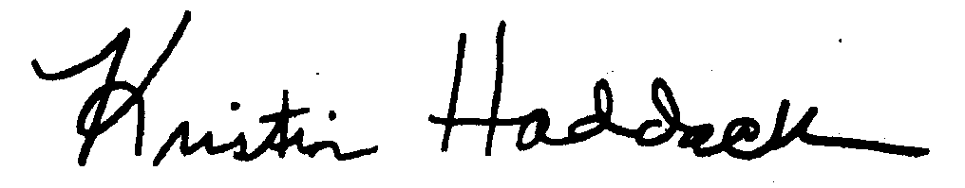
Kristin Haddock, Town Clerk

