Meeting Notice and Agenda
Town Board of Trustees
Regular Meeting
December 11, 2018 - 6:00 pm
Mounds Community Building
15 W 14th St, Mounds, OK 74047
1. Call to Order Time __________
2.Roll Call
Jackson, R ___ Reynolds ___ Ingham ___ Jackson, D ___ Ford ___
3. Invocation
4. Pledge of Allegiance
5. Consent Agenda (A-I)
All matters listed under the “Consent “are considered by the Town Board to be routine and will be enacted by one motion. Any Trustee, however, can remove an item from the Consent Agenda by request.
A. Approval of the minutes of the November 13, 2018 Regular Board Meeting
B. Approval of the Library report.
C. Approval of the Police report
D. Approval of the Fire report
E. Approval of the Financial report.
F. Approval of the Budget report.
G. Approval of the Court report.
H. Approval of the Purchase Orders for General Government, Fire Department and Court Fund.
I. Approval of the Purchase Orders for Streets & Alleys and Parks Depts.

Motion ___________________________ Second __________________
Roll call: Jackson, R ___ Reynolds ___ Ingham ___ Jackson, D ___ Ford ___
6. Building Inspector Report

7. Larry Hall
Discuss, consider and take possible action on Larry Hall’s request to drive his ATV or Buck Truck on the side streets with a permit.
Motion ___________________________ Second __________________
Roll call: Jackson, R ___ Reynolds ___ Ingham ___ Jackson, D ___ Ford ___
8. Newt Stephens
Motion ___________________________ Second __________________
Roll call: Jackson, R ___ Reynolds ___ Ingham ___ Jackson, D ___ Ford ___
9. Christmas Gift Cards and One Time Pay Increase
Discuss, consider and take possible action on purchasing Christmas gift cards and a onetime pay increase
Motion ___________________________ Second __________________
Roll call: Jackson, R ___ Reynolds ___ Ingham ___ Jackson, D ___ Ford ___
10. Annexation
Discuss, consider and take possible action on Annexing 181st, 191st, 49th West Avenue roads and not houses
Motion ___________________________ Second __________________
Roll call: Jackson, R ___ Reynolds ___ Ingham ___ Jackson, D ___ Ford ___
11. New Patrol Cars
Discuss, consider and take possible action on issues with patrol cars and possibility of purchasing newer cars from Kansas Highway Patrol
Motion ___________________________ Second __________________
Roll call: Jackson, R ___ Reynolds ___ Ingham ___ Jackson, D ___ Ford ___
12. Southfield
Discuss, consider and take possible action on Southfield Mobile Home application.
Motion ___________________________ Second __________________
Roll call: Jackson, R ___ Reynolds ___ Ingham ___ Jackson, D ___ Ford ___
13. Executive Session
The Board will consider retiring into Executive Session for the purpose of discussion for the purpose of discussion related to Item 1. The employment, hiring, appointment, promotion, demotion, disciplining or resignation of individual salaried public officer or employee (Police Department), in accordance with O.S. Title 25, Section 307(B)(1). Item 2. Purpose of discussion related to an economic development project pursuant to O.S. Title 25, Section 307(C)(10).
Time: ____
Motion _____________________ Second _______________________
Roll Call: Jackson, R ___ Reynolds ____ Ingham ___ Jackson, D ___ Ford ___

- Board will consider and take any action deemed appropriate, as pertains to Item 1

Motion _____________________ Second _______________________
Roll Call: Jackson, R ___ Reynolds ___ Ingham ___ Jackson, D____ Ford ___

- Board will consider and take any action deemed appropriate, as pertains to Item 2

Motion _____________________ Second _______________________
Roll Call: Jackson, R ___ Reynolds ___ Ingham ___ Jackson, D____ Ford ___

14. Adjournment Time _______________
This agenda was filed in the office of the Town Clerk and posted at _6__ pm on December 11, 2018 at the Mounds Municipal Building located at 1319 Commercial Ave, Mounds, OK 74047 and the Mounds Community Building located at 15 W 14th St, in Mounds, OK 74047, by Town Clerk Kristin Haddock.

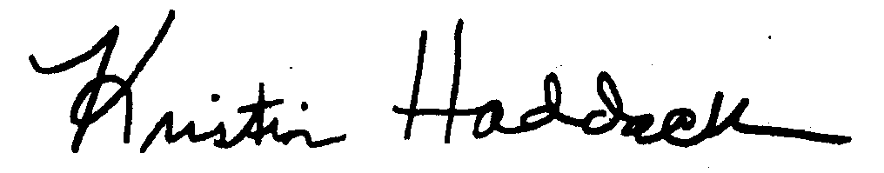
Kristin Haddock Town Clerk

