MEETING NOTICE AND AGENDA

Town Board of Trustees
Regular PWA Meeting
December 11, 2018 – 6:00 pm
Mounds Community Building
15 W 14th St, Mounds OK 74047

- Call to Order Time _________

- Roll Call

Jackson, D ___ Reynolds ___ Ingham ____ Jackson, R ___ Ford ___

- Consent Agenda (A-D)
All matters listed under “Consent” are considered by the Town Board to be routine and will be enacted by one motion. Any Trustee, however, can remove an item from the Consent Agenda by request.
- Approval of the Minutes for the November 13, 2018 Regular Meeting
- Approval of the Streets & Alley and Parks report
- Approval of the Treasurer’s report.
- Approval of the Budget report.

Motion _____________________ Second ________________________

Roll Call: Jackson, R ___ Reynolds ___ Jackson, D____ Ingham ___ Ford ___

- Adjournment Time ______________

This agenda was filed in the office of the Town Clerk and posted at _6__ pm on December 10, 2018 at the Mounds Municipal Building located at 1319 Commercial Ave, Mounds, OK 74047 and the Mounds Community Building located at 15 W 14th St, in Mounds, OK 74047, by Town Clerk Kristin Haddock.

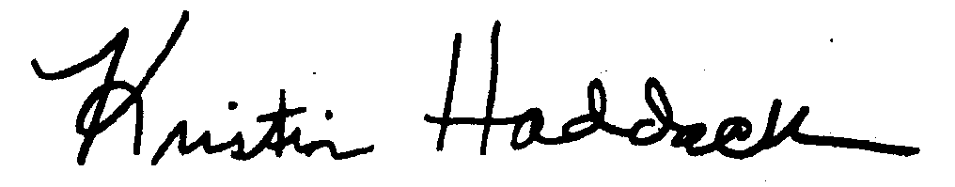

Kristin Haddock Town Clerk

