Meeting Notice and Agenda
Town Board of Trustees
Special Board Meeting
December 27, 2016
6:00 pm
Mounds Community Building
15 W 14th St, Mounds, OK 74047
1. Call to Order Time __________
2. Roll Call
Veale ___ Jackson, D ___ Reynolds ___ Ingham ___ Jackson, R ___
12. Executive Session
The Board will consider retiring into Executive Session for the purpose of discussion related to the employment, hiring, appointment, promotion, demotion, disciplining or resignation of individual salaried public officer or employees (Town Administrator) and to consider individual applications for the position of Police Chief, in accordance with O.S. Title 25, Section 307(B)(1):
Motion _____________________ Second _______________________
Roll call: Veale ___ Jackson, D ___ Reynolds ___ Ingham ___ Jackson, R ___
- Council will consider returning to the Regular Meeting following the Executive Session. Time _______
- Board will consider and take any action deemed appropriate, as a result of the Executive Session.

Motion _____________________ Second _______________________
13. Adjournment Time _______________
This agenda was filed in the office of the Town Clerk and posted at _7__ pm on December 22, 2016 at the Mounds Municipal Building located at 1319 Commercial Ave, Mounds, OK 74047 and the Mounds Community Building located at 15 W 14th St, in Mounds, OK 74047, by Town Clerk Kristin Haddock.
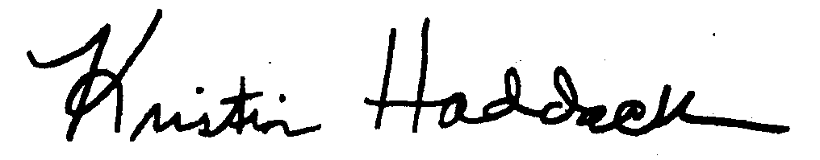
_
Kristin Haddock Town Clerk

