Meeting Notice and Agenda
Town Board of Trustees
Regular Meeting
December 6, 2022 – 6:00 pm
Mounds Community Building
15 W 14th Street, Mounds OK 74047

1. Call to Order
2. Roll Call
3. Consent Agenda (A-K)
All matters listed under “Consent” are considered by the Town Board to be routine and will be enacted by one motion. Any Trustee, however, can remove an item from the Consent Agenda by request.

A. Approval of the Minutes for the November 1, 2022, Regular Board Meeting
B. Approval of the Library report
C. Approval of the Police report
D. Approval of the Fire report
E. Approval of the Financial report
F. Approval of the Budget report
G. Approval of the Court report
I. Approval of Purchase Orders for Streets & Alleys and Parks Departments
J. Building Inspector Report
K. Approval of the Purchase Orders for General Government, Fire Department, and Court Fund

4. 2023 Calendars
Discuss, consider, and take possible action on the 2023 Calendar for the City.

5. Devin McDonald Lot Split
Discuss, consider, and take possible action on Devin McDonald’s Lot Split

6. Digital Sign
Discuss, consider, and take possible action on purchasing a digital sign

7. City Hall/Police Department
Discuss, consider, and take possible action on City Hall/Police Department building

8. Resolution 20221206
Discuss, consider, and take possible action on Resolution 20221206 Elections

9. INCOG grant project
Discuss, consider, and take possible action on selecting an INCOG grant project.

10. Community Jump Start Program
Discuss, consider, and take possible action on the Community Jump Start Program
12. Adjournment

This Agenda was filed in the office of the Town Clerk and posted at 6 PM on December 5, 2022, at the Mounds Municipal Building located at 1319 Commercial Avenue, Mounds, OK 74047 and the Mounds Community Building located at 15 W 14th Street in Mounds, OK 74047, by Town Clerk Kristin Haddock.

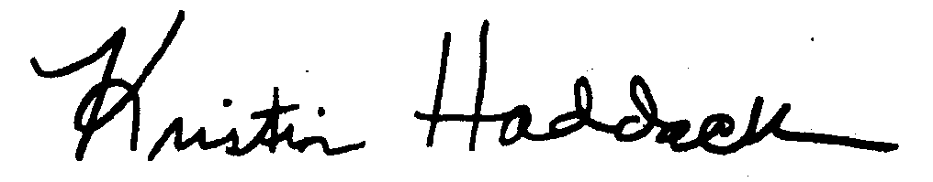
Kristin Haddock, Town Clerk

