Meeting Notice and Agenda
Town Board of Trustees
Regular Meeting
February 15, 2022 - 6:00 pm
Mounds Community Building
15 W 14th St, Mounds, OK 74047

1. Call to Order
2. Roll Call
3. Consent Agenda (A-I)
All matters listed under the “Consent “are considered by the Town Trustees to be routine and will be enacted by one motion. Any Trustee, however, can remove an item from the Consent Agenda by request.
A. Approval of the minutes of the January 11, 2022, Regular Board Meeting
B. Approval of the Library report.
C. Approval of the Police report
D. Approval of the Fire report
E. Approval of the Financial report.
F. Approval of the Budget report.
G. Approval of the Court report.
H. Approval of the Purchase Orders for General Government, Fire Department and Court Fund.
I. Approval of the Purchase Orders for Streets & Alleys and Parks Depts.
J. Approval of the Building Inspector report.
K. Approval of the Streets & Alley and Parks report
L. Approval of bad debt write-off Rose Leffler$11.72 sewer, $69 Trash, $19.50 Fire, and $13 for Beautification fund
4.May 10, 2022, meetings
Discuss, consider, and take possible action on rescheduling May 10th Regular and PWA meeting.
5. Car Show

Discuss, consider, and take possible action on approving the Car Show for Oct. 2022

6. Cemetery Ordinance

Discuss, consider, and take possible action on a Cemetery Ordinance
7. Sump Pump
Discuss, consider, and take possible action on replacing the sump pump with check valve and drain line for $1,350.
8. Fire Dues price increase
Discuss, consider, and take possible action on increasing the residential dues to $60/year and Commercial to $200/yr. with auditing to make sure businesses are paying at the proper rate.
9. Fire Department sale of Brush 7 tanker
Discuss, consider, and take possible action on the Fire Department selling the “Brush 7” tanker.
10. State CDBG Grant
Discuss, consider and take possible action on applying for State CDGB grant administered by INCOG for up to $600,000 for wastewater system improvements.
11. Engineering Firm
Discuss, consider, and take possible action on hiring an engineering firm to conduct pre-engineering study for state CDBG grant
12. City Hall Project
Discuss, consider, and take possible action on an update of the status of the new city hall project, including a presentation from the architect of the development.
13. Easter Egg Hunt
Discuss, consider, and take possible action on having an Easter Egg hunt on April 9th with a contingency date of April 16th.
14. Executive Session
The Trustees will consider retiring into Executive Session for the purpose of discussion for item A. related to the employment, hiring, appointment, promotion, demotion of individual salaried (A. Jim Danforth, B. Lucille Abbott, & C. Theda Boydston) making permanent for benefit purposes in accordance with O.S. Title 25, Section 307(B)(1).

- Trustees will consider and take any action deemed appropriate to Jim Danforth
- Trustees will consider and take any action deemed appropriate to Lucille Abbott
- Trustees will consider and take any action deemed appropriate to Theda Boydston
15. Adjournment Time _______________
This agenda was filed in the office of the Town Clerk and posted at _6__ pm on February 14, 2022, at the Mounds Municipal Building located at 1319 Commercial Ave, Mounds, OK 74047 and the Mounds Community Building located at 15 W 14th St, in Mounds, OK 74047, by Town Clerk.

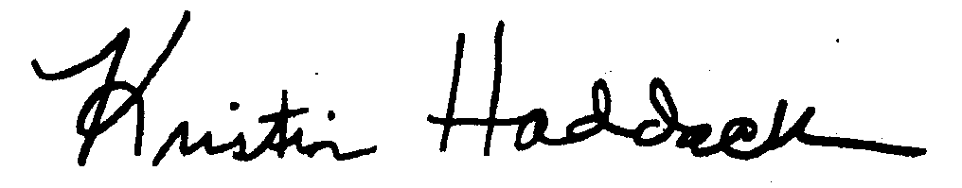
_______________________
Town Clerk, Kristin Haddock

