MEETING NOTICE AND AGENDA

Town Board of Trustees
Regular PWA Meeting
February 15, 2022 – 6:00 pm
Mounds Community Building
15 W 14th St, Mounds OK 74047

- Call to Order

- Roll Call

3. Invocation
4. Pledge of Allegiance
5. Consent Agenda (A-D)
All matters listed under “Consent” are considered by the Town Board to be routine and will be enacted by one motion. Any Trustee, however, can remove an item from the Consent Agenda by request.
A. Approval of the Minutes for the January 11, 2022, Regular Meeting
B. Approval of the Treasurer’s report.
C. Approval of the Budget report.

6. Adjournment

This agenda was filed in the office of the Town Clerk and posted at _6__ pm on February 14, 2022 at the Mounds Municipal Building located at 1319 Commercial Ave, Mounds, OK 74047 and the Mounds Community Building located at 15 W 14th St, in Mounds, OK 74047, by Town Clerk Kristin Haddock.

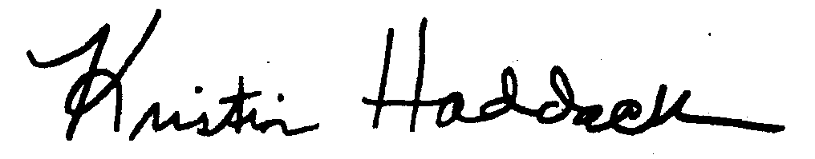
_____________________________
Kristin Haddock Town Clerk

