Meeting Notice and Agenda
Town Board of Trustees
Regular Meeting
February 7, 2023 – 6:30 pm
Mounds Community Building
15 W 14th Street, Mounds OK 74047

- Call to Order

- Roll Call

3. Consent Agenda (A-K)
All matters listed under “Consent” are considered by the Town Board to be routine and will be enacted by one motion. Any Trustee, however, can remove an item from the Consent Agenda by request.

A. Approval of the Minutes for the January 17, 2023, Regular Board Meeting
B. Approval of the Library report
C. Approval of the Police report
D. Approval of the Fire report
E. Approval of the Financial report
F. Approval of the Budget report
G. Approval of the Court report
I. Approval of Purchase Orders for Streets & Alleys and Parks Departments
J. Building Inspector Report
K. Approval of the Purchase Orders for General Government, Fire Department, and Court Fund

4. Tour de Tulsa
Discuss, consider, and take possible action on Tour de Tulsa using Greer Park

5. Mounds Cemetery Association
Discuss, consider, and take possible action on relocation of funds for the Mounds Cemetery Association

6. City Hall/Police Department
Discuss, consider, and take possible action on City Hall/Police Department building

7. Gravel for alley
Discuss, consider, and take possible action on gravel for alley between 10th and 11th

8. Executive Session
The Trustees will consider retiring into Executive Session for the purpose of discussion for item A. related to the employment, hiring, appointment, promotion, demotion of individual salaried (Fire Department) making permanent for benefit purposes in accordance with O.S. Title 25, Section 307(B)(1).

- Trustees will consider and take any action deemed appropriate to Fire Department

9. Adjournment

This Agenda was filed in the office of the Town Clerk and posted at 6 PM on February 6, 2023, at the Mounds Municipal Building located at 1319 Commercial Avenue, Mounds, OK 74047 and the Mounds Community Building located at 15 W 14th Street in Mounds, OK 74047, by Town Clerk Kristin Haddock.

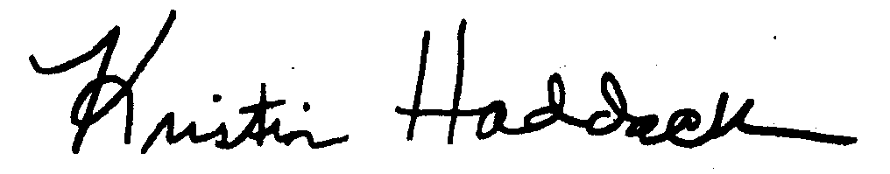
Kristin Haddock, Town Clerk

