MEETING NOTICE AND AGENDA

Town Board of Trustees
Regular PWA Meeting
January 12, 2017 – 6:00 pm
Mounds Community Building
15 W 14th St, Mounds OK 74047

- Call to Order Time _________

- Roll Call
Veale ___ Jackson, D ___ Reynolds ___ Ingham ____ Jackson, R ___
- Consent Agenda (A-D)
All matters listed under “Consent” are considered by the Town Board to be routine and will be enacted by one motion. Any Trustee may, however, remove an item from the Consent Agenda by request.
- Approval of the Minutes for the December 12, 2016 Special PWA meeting.
- Approval of the Streets & Alley and Parks report
- Approval of the Treasurer’s report.
- Approval of the Budget report.

Motion _____________________ Second ________________________

Roll Call: Veale ___ Jackson, D____ Reynolds ___ Ingham ___ Jackson, R ___
- Adjournment Time ______________

This agenda was filed in the office of the Town Clerk and posted at _6__ pm on January 9, 2017 at the Mounds Municipal Building located at 1319 Commercial Ave, Mounds, OK 74047 and the Mounds Community Building located at 15 W 14th St, in Mounds, OK 74047, by Town Clerk Kristin Haddock.
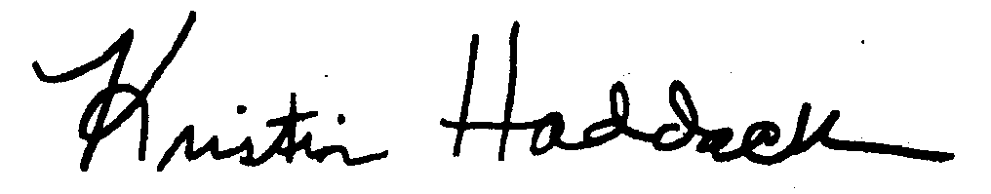
_
Kristin Haddock Town Clerk

