Meeting Notice and Agenda
Town Board of Trustees
Regular Meeting
July 12, 2022 – 6:00 pm
Mounds Community Building
15 W 14th Street, Mounds OK 74047

- Call to Order

2. Roll Call

3. Consent Agenda (A-K)

All matters listed under “Consent” are considered by the Town Board to be routine and will be enacted by one motion. Any Trustee, however, can remove an item from the Consent Agenda by request.

A. Approval of the Minutes for the June 14, 2022, Regular Board Meeting
B. Approval of the Library report
C. Approval of the Police report
D. Approval of the Fire report
E. Approval of the Financial report
F. Approval of the Budget report
G. Approval of the Court report
I. Approval of Purchase Orders for Streets & Alleys and Parks Departments
J. Building Inspector Report
K. Mayor’s Report
L. Approval of the Purchase Orders for General Government, Fire Department, and Court Fund

4. Public Hearing

Discuss, consider, and take possible action on public hearing for special exception on 2 Circle S. Drive
5. Court date
Discuss, consider, and take possible action on moving the court date from July 26, 2022, to August 2, 2022

6. Back-to-School Event

Discuss, consider, and take possible action on a back-to-school event to be held outside of the community building

7. Port-a-Potties

Discuss, consider, and take possible action on putting port-a-potties in the park

8. Voyager

Discuss, consider, and take possible action on increasing credit limit on Voyager

9. Adjournment

This Agenda was filed in the office of the Town Clerk and posted at 6 PM on July 11, 2022, at the Mounds Municipal Building located at 1319 Commercial Avenue, Mounds, OK 74047 and the Mounds Community Building located at 15 W 14th Street in Mounds, OK 74047, by Town Clerk Kristin Haddock.

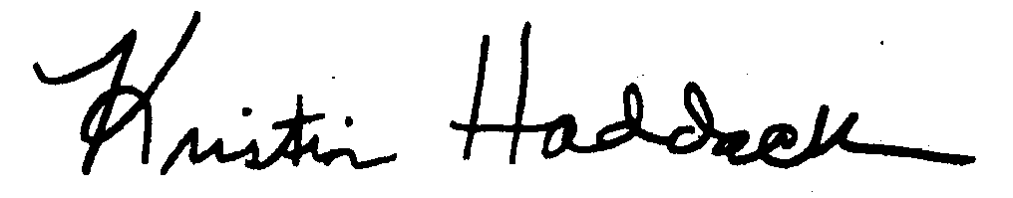
Kristin Haddock, Town Clerk

