0 MEETING NOTICE AND AGENDA

Town Board of Trustees
Special Town Meeting
July 19, 2022 – 6:00 pm
Mounds Community Building
15 W 14th St, Mounds OK 74047

- Call to Order Time _________

- Roll Call

Culbert _____ Veale _____ Jackson _____ Long _____ Dossey _____

- New City Hall
Discuss, consider, and take possible action on the new City Hall

Motion: ____________________________ Second: _____________________________

Culbert _____ Veale _____ Jackson _____ Long _____ Dossey _____

4. Adjournment Time ______________

This agenda was filed in the office of the Town Clerk and posted at 6 pm on July 18, 2022, at the Mounds Municipal Building located at 1319 Commercial Ave, Mounds, OK 74047 and the Mounds Community Building located at 15 W 14th St, in Mounds, OK 74047

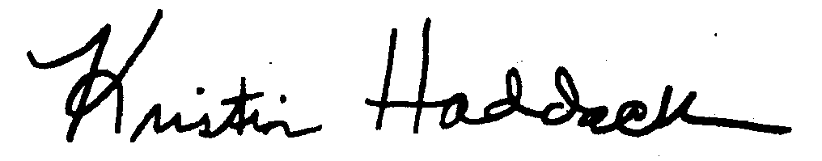
______________________________
Kristin Haddock Town Clerk

