Meeting Notice and Agenda
Town Board of Trustees
Regular Meeting
July 20, 2021 - 6:00 pm
Mounds Community Building
15 W 14th St, Mounds, OK 74047

1. Call to Order
2. Roll Call
3. FiberLink
Discuss, consider, and take possible action on request by FiberLink for Town of Mounds to participate in joint application for a National Telecommunications and Information Administration (NTIA) grant to expand Broadband Infrastructure in the Town of Mounds.
4. Consent Agenda (A-I)
All matters listed under the “Consent “are considered by the Town Trustees to be routine and will be enacted by one motion. Any Trustee, however, can remove an item from the Consent Agenda by request.
A. Approval of the minutes of the June 15, 2021, Regular Board Meeting and June 30, 2021 Special Meeting.
B. Approval of the Library report.
C. Approval of the Police report
D. Approval of the Fire report
E. Approval of the Financial report.
F. Approval of the Budget report.
G. Approval of the Court report.
H. Approval of the Purchase Orders for General Government, Fire Department and Court Fund.
I. Approval of the Purchase Orders for Streets & Alleys and Parks Depts.
5. Executive Session
The Trustees will consider retiring into Executive Session for the purpose of discussion and related to, Item A. the appointment of an individual Trustee to the Board of Trustees of the Town of Mounds, in accordance with O.S. Title 25, Section 307(B)(1).
Item. B. related to the employment, hiring, appointment, promotion, demotion of individual
salaried (Police Department) making permanent for benefit purposes in accordance with O.S.
Title 25, Section 307(B)(1).
Item A. Trustees will consider and take any action on appointing a new Trustee to fill vacant position.
Item B. Trustees will consider and take any action deemed appropriate to Police Department
Item C: The Town Clerk will administer the oath to the appointed trustee.
6. Building Inspector Report
Discuss, consider, and take possible action on Building Inspector
7. Trash Contract
Discuss, consider, and take possible action on putting trash contract out for bid.
8. Worker’s Compensation
Discuss, consider, and take possible action on allocation of worker’s compensation funds
9. Harmon Lot Split
Discuss, consider, and take possible action on Harmon Lot Split (4 Circle S Drive)
10. Signer

Discuss, consider, and take possible action on adding appointed trustee as a signer to all bank accounts

11. Main Street Trick or Treat Proposal
Discuss, consider, and take possible action on Main Street Trick or Treat Proposal - Melodie Reader
12. ODOT
Discuss, consider, and take possible action on the purchase of ODOT land currently being leased
13. Copier
Discuss, consider, and take possible action on the lease/purchase of new copier for city hall
14. Bid for dunk tank
Discuss, consider, and take possible action on opening and awarding bid on dunk tank
15. Citizen Complaint
The Board will hear a citizen complaint by Ray and Mary Pyle and consider and take possible action.
16. Board Planning Workshop
The Board will discuss and possibly schedule a board workshop in order to (a) participate in OMAG training and (b) discuss ling range plans for the town
17. Adjournment

This agenda was filed in the office of the Town Clerk and posted at _6__ pm on July 19, 2021, at the Mounds Municipal Building located at 1319 Commercial Ave, Mounds, OK 74047 and the Mounds Community Building located at 15 W 14th St, in Mounds, OK 74047, by Town Clerk.

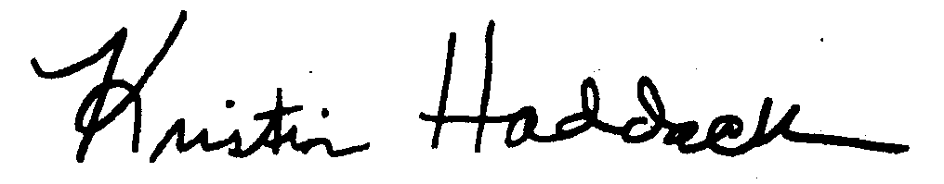
_______________________
Town Clerk

