MEETING NOTICE AND AGENDA

Town Board of Trustees
Regular PWA Meeting
July 20, 2021 – 6:00 pm
Mounds Community Building
15 W 14th St, Mounds OK 74047

- Call to Order
- Roll Call
- Invocation
- Pledge of Allegiance
- Consent Agenda (A-D)
All matters listed under “Consent” are considered by the Town Board to be routine and will be enacted by one motion. Any Trustee, however, can remove an item from the Consent Agenda by request.
A. Approval of the Minutes for the June 15, 2021 Regular Meeting
B. Approval of the Streets & Alley and Parks report
C. Approval of the Treasurer’s report.
D. Approval of the Budget report.

Adjournment

This agenda was filed in the office of the Town Clerk and posted at _6__ pm on July 19, 2021 at the Mounds Municipal Building located at 1319 Commercial Ave, Mounds, OK 74047 and the Mounds Community Building located at 15 W 14th St, in Mounds, OK 74047, by Town Clerk

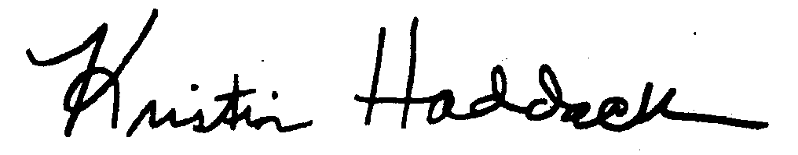
_____________________________
Town Clerk

