Meeting Notice and Agenda
Town Board of Trustees
Regular PWA Meeting
June 14, 2022 – 6:00 pm
Mounds Community Building
15 W 14th Street, Mounds OK 74047

1. Call to Order
2. Roll Call
3. Invocation
4. Pledge of Allegiance
5. Consent Agenda

All Matters listed under “Consent” are considered by the Town Board to be routine and will be enacted by one motion. Any Trustee, however, can remove an item from the Consent Agenda by request.

A. Approval of the Minutes for the May 17, 2022, PWA Meeting
B. Approval of the Treasurer’s Report
C. Approval of the Budget Report
D. Approval of the PWA Report
E. Approval of Purchase Orders for PWA
Motion: _________________________ Second: _________________________
Culbert _____ Veale _____ Jackson _____ Long _____ Dossey _____

6. Adjournment

This Agenda was filed in the office of the Town Clerk and posted at 6 PM on June 13, 2022, at the Mounds Municipal Building located at 1319 Commercial Avenue, Mounds, OK 74047 and the Mounds Community Building located at 15 W 14th Street in Mounds, OK 74047, by Town Clerk Kristin Haddock.

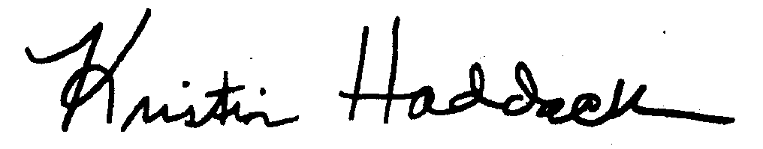
Kristin Haddock, Town Clerk

