Meeting Notice and Agenda
Town Board of Trustees
Regular Meeting
June 14, 2022 – 6:00 pm
Mounds Community Building
15 W 14th Street, Mounds OK 74047

1. Call to Order

2. Roll Call

3. Consent Agenda (A-K)
All matters listed under “Consent” are considered by the Town Board to be routine and will be enacted by one motion. Any Trustee, however, can remove an item from the Consent Agenda by request.

A. Approval of the Minutes for the May 17, 2022, Regular Board Meeting
B. Approval of the Library report
C. Approval of the Police report
D. Approval of the Fire report
E. Approval of the Financial report
F. Approval of the Budget report
G. Approval of the Court report
I. Approval of Purchase Orders for Streets & Alleys and Parks Departments
J. Building Inspector Report
K. Mayor’s Report
L. Approval of the Purchase Orders for General Government, Fire Department, and Court Fund

4. Public Hearing 2022-2023 Budget

5. 2022-2023 Budgets

Discuss, consider, and take possible action on the 2022-2023 budgets

6. Resolution 21220614 Fireworks

Discuss, consider, and take possible action on resolution 21220614 Fireworks

7. Smith Family Fireworks

Discuss, consider, and take possible action on fireworks contract with Smith Family fireworks

8. Addendum to March 8, 2022, Minutes

Discuss, consider, and take possible action on updating March 8, 2022, minutes, line item #12 from: Jeff Culbert made a motion effective to raise residential fire subscriptions to $60/year and raise commercial subscriptions to $120/year effective July 1, 2022. Rosa Jackson seconded the motion.

To: Jeff Culbert made a motion to raise all residential fire rates at $1.00 a month with rural rates now at $60 a year and in town rates of $30, commercial rates are $120 a year. This will be effective July 1, 2022.

9. 2022 CDBG Lagoon Fence Budget

Discuss, consider, and take possible action on the 2022 CDBG Lagoon Fence Budget

10. ARPA Library Grant Budget
Discuss, consider, and take possible action on the ARPA Library Grant budget

11. Worker’s Compensation
Discuss, consider, and take possible action on allocating Worker’s Compensation Escrow Funds

12. Transfer of Funds
Discuss, consider, and take possible action regarding the transfer of $300 from Juvenile Justice to General Fund (VISTA Grant)

13. Sewer rates
Discuss, consider, and take possible action on sewer rates.

14. City Hall/Police Station
Discuss, consider, and take possible action on the new City Hall/Police Station

15. Special Exception
Discuss, consider, and take possible action on 2 Circle Drive special exception.

16. Contract
Discuss, consider, and take possible action on the contract with auditor April Adams, CPA

17. Adjournment

This Agenda was filed in the office of the Town Clerk and posted at 6 PM on June 13, 2022, at the Mounds Municipal Building located at 1319 Commercial Avenue, Mounds, OK 74047 and the Mounds Community Building located at 15 W 14th Street in Mounds, OK 74047, by Town Clerk Kristin Haddock.

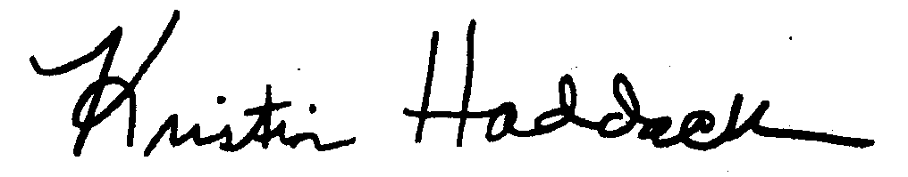
Kristin Haddock, Town Clerk

