Meeting Notice and Agenda
Town Board of Trustees
Regular Meeting
June 15, 2021 - 6:00 pm
Mounds Community Building
15 W 14th St, Mounds, OK 74047

1. Call to Order
2. Roll Call
3. Consent Agenda (A-I)
All matters listed under the “Consent “are considered by the Town Trustees to be routine and will be enacted by one motion. Any Trustee, however, can remove an item from the Consent Agenda by request.
A. Approval of the minutes of the May 18, 2021 Regular Board Meeting, April 28, 2021, May 3, 2021, and May 10, 2021 Special Meeting minutes.
B. Approval of the Library report.
C. Approval of the Police report
D. Approval of the Fire report
E. Approval of the Financial report.
F. Approval of the Budget report.
G. Approval of the Court report.
H. Approval of the Purchase Orders for General Government, Fire Department and Court Fund.
I. Approval of the Purchase Orders for Streets & Alleys and Parks Depts.
4. Resignation
Discuss, consider and take possible action on Gary Cupps’ Jr. resignation as the Town of Mounds Trustee effective May 31, 2021, and removing Gary Cupps Jr. as a signer for all Town of Mounds bank accounts.
5. Public Hearing Time: ______
6. Discussion
Discuss, consider and take possible action on Public Hearing statements
7. Building Inspector Report
Discuss, consider, and take possible action on Building Inspector
8. CDBG Sewer Lagoon Rehabilitation Project.
Discuss, consider and take possible action on awarding the bid to the lowest bidder based on recommendation from Parkhill/Cardinal Engineering for CDBG Sewer Lagoon Rehabilitation Project.
9. Award Contract
Discuss, consider and take possible action on approving the Notice of Contract Award to the above Line Item 8 for the CDBG Sewer Lagoon Rehabilitation Project.
10. Sealed Bids
Discuss, consider and take possible action on opening sealed bids for 2021 REAP Grant for Lagoon fencing.
11. Plan Reviews
Discuss, consider, and take possible action on establishing plan reviews fees
12. Dunk Tank
Discuss, consider and take possible action on scrapping the dunk tank
13. Brittany Woods
Discuss, consider and take possible action on Brittany Woods mobile move-in permit
14. Fireworks
Discuss, consider and take possible action on fireworks contract
15. VISA Grant
Discuss, consider and take possible action on VISA grant contract
16. 2021-2022 Budget
Discuss, consider and take possible action on 2021-2022 Budget
17. City Hall Project
Discuss, consider and take possible action on the City Hall project, including but not limited to budget and funding, design, and steps needed to get to construction.
18. Okmulgee County Fire Tax
Discuss, consider and take possible action the status Okmulgee County Fire Tax
19. 30 ft roll-off dumpster
Discuss, consider, and take possible action on the purchase of a 30 ft roll-off dumpster out of beautification fund for $6,500 to be placed by sewer plant.
20. Resolution 20210615
Discuss, consider, and take possible action on Resolution 20210615 establishing dates fireworks can be sold and shot off within city limits.
21. Executive Session
The Trustees will consider retiring into Executive Session for the purpose of discussion for item A. related to the employment, hiring, appointment, promotion, demotion of individual salaried (Police Department) making permanent for benefit purposes in accordance with O.S. Title 25, Section 307(B)(1).
22. Adjournment

This agenda was filed in the office of the Town Clerk and posted at _6__ pm on June 14, 2021, at the Mounds Municipal Building located at 1319 Commercial Ave, Mounds, OK 74047 and the Mounds Community Building located at 15 W 14th St, in Mounds, OK 74047, by Town Clerk

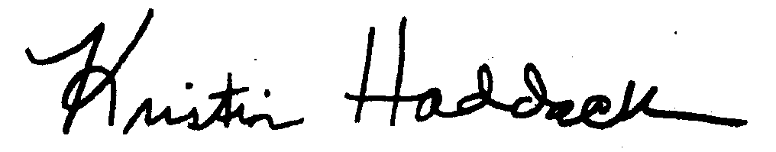
_______________________
Town Clerk

