MEETING NOTICE AND AGENDA
Town Board of Trustees
Regular PWA Meeting
June 15, 2021 – 6:00 pm
Mounds Community Building
15 W 14th St, Mounds OK 74047

- Call to Order

- Roll Call

- Invocation

4. Pledge of Allegiance
5. Consent Agenda (A-D)
All matters listed under “Consent” are considered by the Town Board to be routine and will be enacted by one motion. Any Trustee, however, can remove an item from the Consent Agenda by request.
A. Approval of the Minutes for the May 18, 2021 Regular Meeting
B. Approval of the Streets & Alley and Parks report
C. Approval of the Treasurer’s report.
D. Approval of the Budget report.

6. CDBG Grant
Discuss, consider and take possible action for Town of Mounds to use $30,000 fence grant to add to CDBG Grant and pay the difference out of PWA savings.
7. Adjournment

This agenda was filed in the office of the Town Clerk and posted at _6__ pm on June 14, 2021 at the Mounds Municipal Building located at 1319 Commercial Ave, Mounds, OK 74047 and the Mounds Community Building located at 15 W 14th St, in Mounds, OK 74047, by Town Clerk.

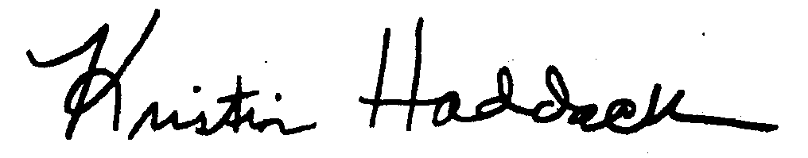
_____________________________
Town Clerk

