Meeting Notice and Agenda
Town Board of Trustees
Special Board Meeting
June 30, 2021
5:30 pm
Mounds Community Building
15 W 14th St, Mounds, OK 74047

1. Call to Order Time __________
2. Roll Call
Jackson, R ___ Veale, A ___ Culbert, J ___ Long, K ___
3. Wastewater Improvement Project
Discuss, consider, and take possible action awarding MJM Construction and Application, LLC. For the Wastewater Improvement Project (Lagoon Improvements) 17807 CDBG 19
Motion _____________________ Second _______________________
Jackson, R ___ Veale, A ___ Culbert, J ___ Long, K ___
4. Charge Order
Discuss, consider, and take possible action on Change Order #1 for the Wastewater Improvement Project (Lagoon Improvements) 17807 CDBG 19 to reduce the quantities of materials for the project.
Motion _____________________ Second _______________________
Jackson, R ___ Veale, A ___ Culbert, J ___ Long, K ___
5. Adjournment Time _______________
This agenda was filed in the office of the Town Clerk and posted at _6 pm on June 28, 2021, at the Mounds Municipal Building located at 1319 Commercial Ave, Mounds, OK 74047 and the Mounds Community Building located at 15 W 14th St, in Mounds, OK 74047, by Town Clerk Kristin Haddock.

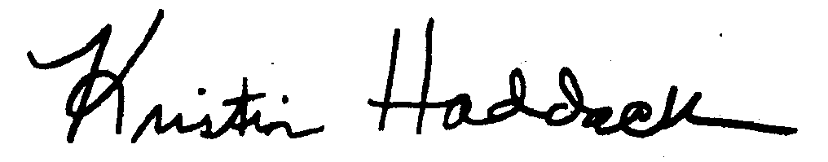
Kristin Haddock Town Clerk

