Meeting Notice and Agenda
Town Board of Trustees
Regular Meeting
June 4, 2019 - 6:00 pm
Mounds Community Building
15 W 14th St, Mounds, OK 74047
1. Call to Order Time __________
2. Roll Call
Jackson, R ___ Veale ___ Cupps ___ Culbert ___ Ford ___
3. Invocation
4. Pledge of Allegiance
5. Consent Agenda (A-I)
All matters listed under the “Consent “are considered by the Town Board to be routine and will be enacted by one motion. Any Trustee, however, can remove an item from the Consent Agenda by request.
A. Approval of the minutes of the May 14, 2019 Regular Board Meeting
B. Approval of the Library report.
C. Approval of the Police report
D. Approval of the Fire report
E. Approval of the Financial report.
F. Approval of the Budget report.
G. Approval of the Court report.
H. Approval of the Purchase Orders for General Government, Fire Department and Court Fund.
I. Approval of the Purchase Orders for Streets & Alleys and Parks Depts.
Motion ___________________________ Second __________________
Roll call: Jackson, R ___ Veale ___ Cupps ___ Culbert ___ Ford ___
6. Building Inspector Report
7. Adjournment Time _______________
This agenda was filed in the office of the Town Clerk and posted at _6__ pm on June 3, 2019 at the Mounds Municipal Building located at 1319 Commercial Ave, Mounds, OK 74047 and the Mounds Community Building located at 15 W 14th St, in Mounds, OK 74047, by Town Clerk Kristin Haddock.

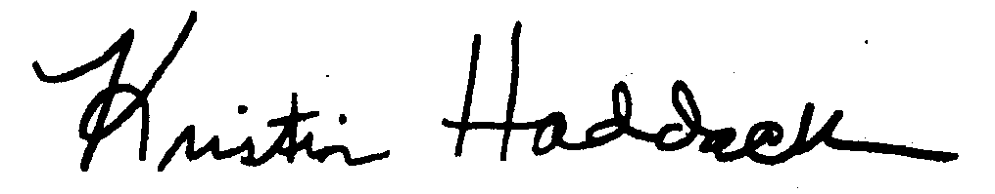
Kristin Haddock Town Clerk

