Meeting Notice and Agenda
Town Board of Trustees
Public Hearing
June 5, 2019 – 6:30 pm
Mounds Community Building
15 W 14th St, Mounds, OK 74047

A Public Hearing has been set for Thursday, June 6, 2018 at 6:30 P.M. at the Mounds Community Building at 15 West 14th Street in Mounds to be held in conjunction with the regularly scheduled Town Board of Trustees meeting. The purpose of the hearing is to receive comments and recommendations on 2019 – 2020 approved Budgets
These comments and recommendations will be considered by the Board of Trustees. Citizens are requested to participate in the hearing to express their views this information. The Town of Mounds Board of Trustees will incorporate any comments or proposals, where feasible.

Posted this 5th day of June at the following locations:
Mounds Municipal Offices
Mounds Community Building
Anyone requiring special accommodations pursuant to the Americans with Disabilities Act should notify the Mounds Municipal Offices at (918) 827-6711.

By:___ 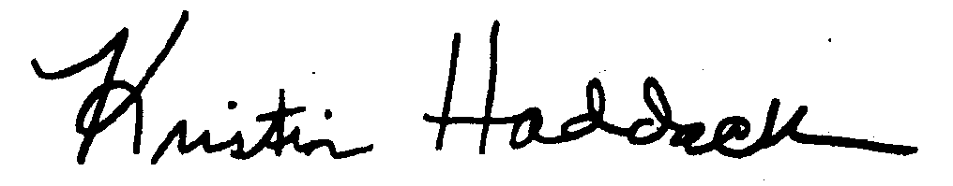__

Kristin Haddock
Town Clerk

