MEETING NOTICE AND AGENDA
Town Board of Trustees
Special Town Meeting
June 6, 2019 – 6:00 pm
Mounds Community Building
15 W 14th St, Mounds OK 74047

- Call to Order Time _________

- Roll Call

Roll call: Jackson, R ___ Veale ___ Cupps ___ Culbert ___ Ford ___
- Public Hearing Time: _____
- Library Budget 2019-2020
Discuss, consider and take possible action on 2019-2020 Library Budget
Motion ___________________________ Second __________________
Roll call: Jackson, R ___ Veale ___ Cupps ___ Culbert ___ Ford ___
- Police Department Budget 2019-2020
Discuss, consider and take possible action on 2019-2020 Police Department Budget.
Motion ___________________________ Second __________________
Roll call: Jackson, R ___ Veale ___ Cupps ___ Culbert ___ Ford ___
- Fire Department Budget 2019-2020
Discuss, consider and take possible action on 2019-2020 Fire Department Budget.
Motion ___________________________ Second __________________
Roll call: Jackson, R ___ Veale ___ Cupps ___ Culbert ___ Ford ___

- City Budget 2019-2020
Discuss, consider and take possible action on 2019-2020 City Budget
Motion ___________________________ Second __________________
Roll call: Jackson, R ___ Veale ___ Cupps ___ Culbert ___ Ford ___

- Court Budget 2019-2020
Discuss, consider and take possible action on 2019-2020 Court Budget
Motion ___________________________ Second __________________
Roll call: Jackson, R ___ Veale ___ Cupps ___ Culbert ___ Ford ___
- Streets & Alleys and Parks Budget 2019-2020
Discuss, consider and take possible action on 2019-2020 Streets, Alleys & Parks Department Budget.
Motion ___________________________ Second __________________
Roll call: Jackson, R ___ Veale ___ Cupps ___ Culbert ___ Ford __
- PWA Budget 2019-2020
Discuss, consider and take possible action on 2019-2020 Streets, Alleys & Parks Department Budget.
Motion ___________________________ Second __________________
Roll call: Jackson, R ___ Veale ___ Cupps ___ Culbert ___ Ford __

- Beautification Budget
Discuss, consider and take possible action on 2019-2020 Beautification Budget
Motion ___________________________ Second __________________
Roll call: Jackson, R ___ Veale ___ Cupps ___ Culbert ___ Ford ___

- Timesheet
Discuss, consider and take possible action on approving timesheet for Police department and the criteria for reporting of time worked
Motion ___________________________ Second __________________
Roll call: Jackson, R ___ Veale ___ Cupps ___ Culbert ___ Ford ___
- Adjournment Time ______________

This agenda was filed in the office of the Town Clerk and posted at 6pm on June 5, 2019 at the Mounds Municipal Building located at 1319 Commercial Ave, Mounds, OK 74047 and the Mounds Community Building located at 15 W 14th St, in Mounds, OK 74047

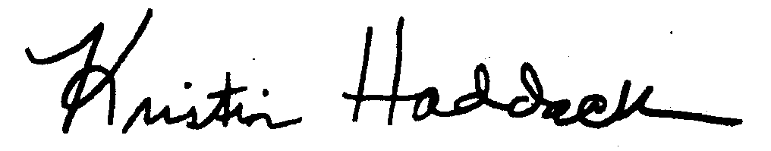
Kristin Haddock Town Clerk

