Meeting Notice and Agenda
Town Board of Trustees
Regular Meeting
March 8, 2022 – 6:00 pm
Mounds Community Building
15 W 14th Street, Mounds OK 74047

1. Call to Order Time: _____________
2. Roll Call
Culbert _____ Veale _____ Jackson _____ Long _____ Dossey _____
3. Consent Agenda (A-K)
All matters listed under “Consent” are considered by the Town Board to be routine and will be enacted by one motion. Any Trustee, however, can remove an item from the Consent Agenda by request.

A. Approval of the Minutes for the February 15, 2022, Regular Board Meeting
B. Approval of the Library report
C. Approval of the Police report
D. Approval of the Fire report
E. Approval of the Financial report
F. Approval of the Budget report
G. Approval of the Court report
H. Approval of the Purchase Orders for General Government, Fire Department, and Court Fund
I. Approval of Purchase Orders for Streets & Alleys and Parks Departments
J. Building Inspector Report
K. Mayor’s Report

Motion: _________________________ Second : _________________________
Culbert _____ Veale _____ Jackson _____ Long _____ Dossey _____
4. Proposed Revenue Budget
Discuss, consider, and take possible action on the 2022-2023 proposed revenue budget
Motion: _________________________ Second : _________________________
Culbert _____ Veale _____ Jackson _____ Long _____ Dossey _____

5. 2022-2023 Budget Calendar
Discuss, consider, and take possible action on the 2022-2023 budget calendar
Motion: _________________________ Second : _________________________
Culbert _____ Veale _____ Jackson _____ Long _____ Dossey _____
6. Resolution 20220308 – Creek County ARPA
Discuss, consider, and take possible action on Resolution 20220308 authorizing 2nd round application for Creek County ARPA funds.
Motion: _________________________ Second : _________________________
Culbert _____ Veale _____ Jackson _____ Long _____ Dossey _____
7. Ordinance 20220308A – Employee Retirement System
Discuss, consider, and take possible action of Ordinance 20220308A amending the employee retirement system.
Motion: _________________________ Second : _________________________
Culbert _____ Veale _____ Jackson _____ Long _____ Dossey _____
8. Library Air Handlers
Discuss, consider, and take possible action to repair or replace air handlers in the library.
Motion: _________________________ Second : _________________________
Culbert _____ Veale _____ Jackson _____ Long _____ Dossey _____
9. Purchase 3000 gallon tanker
Discuss, consider, and take possible action on purchasing a 3000 gallon tanker
Motion: _________________________ Second : _________________________
Culbert _____ Veale _____ Jackson _____ Long _____ Dossey _____
10. Surplus Brush 7
Discuss, consider, and take possible action on declaring Brush 7 as surplus.
Motion: _________________________ Second : _________________________
Culbert _____ Veale _____ Jackson _____ Long _____ Dossey _____
11. 1-time pay increase
Discuss, consider, and take possible action on a 1-time pay increase
Motion: _________________________ Second : _________________________
Culbert _____ Veale _____ Jackson _____ Long _____ Dossey _____
14. 2022-2023 Fire Subscription Rates
Discuss, consider, and take possible action on declaring Brush 7 as surplus.
Motion: _________________________ Second : _________________________
Culbert _____ Veale _____ Jackson _____ Long _____ Dossey _____
15. Fire Department Budget Amendment
Discuss, consider, and take possible action on a budget ammendment
Motion: _________________________ Second : _________________________
Culbert _____ Veale _____ Jackson _____ Long _____ Dossey _____
14. Adjournment
This Agenda was filed in the office of the Town Clerk and posted at 6 PM on March 7, 2022, at the Mounds Municipal Building located at 1319 Commercial Avenue, Mounds, OK 74047 and the Mounds Community Building located at 15 W 14th Street in Mounds, OK 74047, by Town Clerk Kristin Haddock.

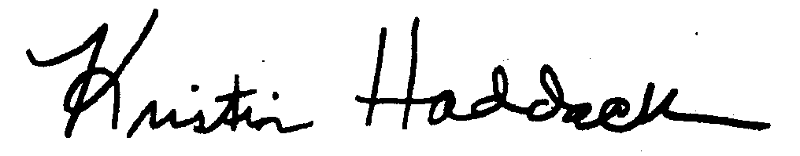
Kristin Haddock, Town Clerk

