Meeting Notice and Agenda
Town Board of Trustees
Regular Meeting
May 14, 2019 - 6:00 pm
Mounds Community Building
15 W 14th St, Mounds, OK 74047

1. Call to Order Time __________
2. Roll Call
Jackson, R ___ Veale ___ Cupps ___ Culbert ___ Ford ___
3. Invocation
4. Pledge of Allegiance
5. Public Hearing Time:___
The Town of Mounds will hold a public hearing to receive public comments and input on the CDBG grant application to update the Town of Mounds Capital Improvement Plan.

6. Consent Agenda (A-I)
All matters listed under the “Consent “are considered by the Town Board to be routine and will be enacted by one motion. Any Trustee, however, can remove an item from the Consent Agenda by request.
A. Approval of the minutes of the April 9, 2019 Regular Board Meeting and May 2, 2019 Special Meeting
B. Approval of the Library report.
C. Approval of the Police report
D. Approval of the Fire report
E. Approval of the Financial report.
F. Approval of the Budget report.
G. Approval of the Court report.
H. Approval of the Purchase Orders for General Government, Fire Department and Court Fund.
I. Approval of the Purchase Orders for Streets & Alleys and Parks Depts.
Motion ___________________________ Second __________________
Roll call: Jackson, R ___ Veale ___ Cupps ___ Culbert ___ Ford ___
7. Building Inspector Report
8. CDBG CIP Grant Application:
Discuss, consider and take possible action on CDBG grant application to update the Town’s Capital Improvement Plan:
- Approve the Project Narrative
Motion ___________________________ Second __________________
Roll call: Jackson, R ___ Veale ___ Cupps ___ Culbert ___ Ford ___

- Approve the Disclosure and Certification
Motion ___________________________ Second __________________
Roll call: Jackson, R ___ Veale ___ Cupps ___ Culbert ___ Ford ___

- Approve the Citizen Participation Plan
Motion ___________________________ Second __________________
Roll call: Jackson, R ___ Veale ___ Cupps ___ Culbert ___ Ford ___

- Approve the Residential Anti-Displacement and Relocation Assistance Plan
Motion ___________________________ Second __________________
Roll call: Jackson, R ___ Veale ___ Cupps ___ Culbert ___ Ford ___

- Resolution 20190514A: Approve the grant application Resolution
Motion ___________________________ Second __________________
Roll call: Jackson, R ___ Veale ___ Cupps ___ Culbert ___ Ford ___

- Resolution 20190514B: Approve the Fair Housing Resolution
Motion ___________________________ Second __________________
Roll call: Jackson, R ___ Veale ___ Cupps ___ Culbert ___ Ford ___

- Resolution 20190514C: Establish the CIP Local Planning Activities Committee
Motion ___________________________ Second __________________
Roll call: Jackson, R ___ Veale ___ Cupps ___ Culbert ___ Ford ___
9. Oklahoma Heartland Heroes
Discuss, consider and take possible action on Penny from Oklahoma Heartland Heroes request to provide lunch, dinner and snacks at the park during summer break.
Motion ___________________________ Second __________________
Roll call: Jackson, R ___ Veale ___ Cupps ___ Culbert ___ Ford ___
10. Jeffrey Byers
Discuss, consider and take possible action on the relocation of the police department antenna from the blue tank on 191st ST S to the tower MidWest Technology put on his property, the termination of the current lease with the Water District for the antenna and a lease with MidWest and/or Byers for the relocated antenna.
Motion ___________________________ Second __________________
Roll call: Jackson, R ___ Veale ___ Cupps ___ Culbert ___ Ford ___

11. Executive Session
The Board will consider retiring into Executive Session for the purpose of discussion for the purpose of discussion related to Item 1. The employment, hiring, appointment, promotion, demotion, disciplining or resignation of individual salaried public officer or employee (Police Department), in accordance with O.S. Title 25, Section 307(B)(1). Item 2. Purpose of discussion related to an economic development project pursuant to O.S. Title 25, Section 307(C) (10).
Time: ____
Motion _____________________ Second _______________________
Roll call: Jackson, R ___ Veale ___ Cupps ___ Culbert ___ Ford ___
- Board will consider and take any action deemed appropriate, as pertains to Item 1

Motion _____________________ Second _______________________
Roll call: Jackson, R ___ Veale ___ Cupps ___ Culbert ___ Ford ___
- Board will consider and take any action deemed appropriate, as pertains to Item 2

Motion _____________________ Second _______________________
Roll call: Jackson, R ___ Veale ___ Cupps ___ Culbert ___ Ford ___
12. Adjournment Time _______________
This agenda was filed in the office of the Town Clerk and posted at _6__ pm on May 13, 2019 at the Mounds Municipal Building located at 1319 Commercial Ave, Mounds, OK 74047 and the Mounds Community Building located at 15 W 14th St, in Mounds, OK 74047, by Town Clerk Kristin Haddock.

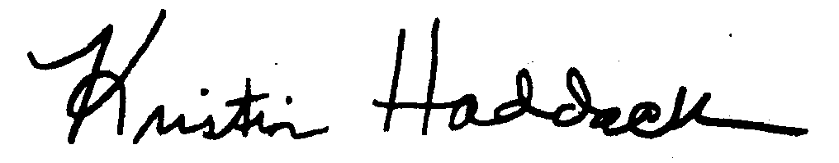
Kristin Haddock Town Clerk

