MEETING NOTICE AND AGENDA

Town Board of Trustees
Special Town Budget Meeting
May 16, 2019 – 6:00 pm
Mounds Community Building
15 W 14th St, Mounds OK 74047

- Call to Order Time _________

- Roll Call

Roll call: Jackson, R ___ Veale ___ Cupps ___ Culbert ___ Ford ___
- Proposed Library Budget 2019-2020
Discuss, consider and take possible action on 2019-2020 proposed Library Budget
Motion ___________________________ Second __________________
Roll call: Jackson, R ___ Veale ___ Cupps ___ Culbert ___ Ford ___
- Proposed Police Department Budget 2019-2020
Discuss, consider and take possible action on 2019-2020 proposed Police Department Budget.
Motion ___________________________ Second __________________
Roll call: Jackson, R ___ Veale ___ Cupps ___ Culbert ___ Ford ___
- Proposed Fire Department Budget 2019-2020
Discuss, consider and take possible action on 2019-2020 proposed Fire Department Budget.
Motion ___________________________ Second __________________
Roll call: Jackson, R ___ Veale ___ Cupps ___ Culbert ___ Ford ___

- Proposed City Budget 2019-2020
Discuss, consider and take possible action on 2019-2020 proposed City Budget
Motion ___________________________ Second __________________
Roll call: Jackson, R ___ Veale ___ Cupps ___ Culbert ___ Ford ___

- Proposed Court Budget 2019-2020
Discuss, consider and take possible action on 2019-2020 proposed Court Budget
Motion ___________________________ Second __________________
Roll call: Jackson, R ___ Veale ___ Cupps ___ Culbert ___ Ford ___
- Proposed Streets & Alleys and Parks Budget 2019-2020
Discuss, consider and take possible action on 2019-2020 proposed Streets, Alleys & Parks Department Budget.
Motion ___________________________ Second __________________
Roll call: Jackson, R ___ Veale ___ Cupps ___ Culbert ___ Ford __

- Proposed PWA Budget 2019-2020
Discuss, consider and take possible action on 2019-2020 proposed Streets, Alleys & Parks Department Budget.
Motion ___________________________ Second __________________
Roll call: Jackson, R ___ Veale ___ Cupps ___ Culbert ___ Ford __

- Proposed Beautification Budget
Discuss, consider and take possible action on 2019-2020 proposed Beautification Budget
Motion ___________________________ Second __________________
Roll call: Jackson, R ___ Veale ___ Cupps ___ Culbert ___ Ford ___

- Street and Alley Grant
Discuss, consider and take possible action on Street and Alley Grant
Motion ___________________________ Second __________________
Roll call: Jackson, R ___ Veale ___ Cupps ___ Culbert ___ Ford ___
- Specific Use Permit Ordinance 20190516
Discuss, consider and take possible action on approval of a Specific Use Permit Ordinance 20190516
Motion ___________________________ Second __________________
Roll call: Jackson, R ___ Veale ___ Cupps ___ Culbert ___ Ford ___
- Emergency Clause
Discuss, consider and take possible action on emergency clause for the Specific use Permit Ordinance.
Motion ___________________________ Second __________________
Roll call: Jackson, R ___ Veale ___ Cupps ___ Culbert ___ Ford ___
- Adjournment Time ______________
This agenda was filed in the office of the Town Clerk and posted at 6pm on May 14, 2019 at the Mounds Municipal Building located at 1319 Commercial Ave, Mounds, OK 74047 and the Mounds Community Building located at 15 W 14th St, in Mounds, OK 74047

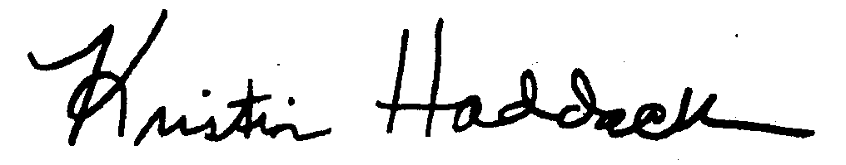
Kristin Haddock Town Clerk

