Meeting Notice and Agenda
Town Board of Trustees
Regular Meeting
May 17, 2022 – 6:00 pm
Mounds Community Building
15 W 14th Street, Mounds OK 74047

1. Call to Order

2. Roll Call

3. Consent Agenda (A-K)

All matters listed under “Consent” are considered by the Town Board to be routine and will be enacted by one motion. Any Trustee, however, can remove an item from the Consent Agenda by request.

A. Approval of the Minutes for the April 12, 2022, Regular Board Meeting
B. Approval of the Library report
C. Approval of the Police report
D. Approval of the Fire report
E. Approval of the Financial report
F. Approval of the Budget report
G. Approval of the Court report
I. Approval of Purchase Orders for Streets & Alleys and Parks Departments
J. Building Inspector Report
K. Mayor’s Report
L. Approval of the Purchase Orders for General Government, Fire Department, and
Court Fund
4. Ordinance 20220517
Discuss, consider, and take possible action on Ordinance 20220517 regarding teen use of tobacco, vape, and ecigs.
5. GPS Trackers
Discuss, consider, and take possible action on upgrading GPS trackers on all city vehicles
6. Sewer rates
Discuss, consider, and take possible action on sewer rates
7. Storm water drainage
Discuss, consider, and take possible action on Jerry Grafton’s property, 702 Russell’s storm water drainage

8. Sewer Line replacement
Discuss, consider, and take possible action on authorizing Creek County to bid Creek County ARPA funded sewer line replacement project on behalf of the town.
9. Budget Amendment
Discuss, consider, and take possible action on adding $360 to Juvenile Justice capital outlay for purchase of new tables for community center and court.
10. City Hall/Police Station
Discuss, consider, and take possible action on bids for new city hall and police station.
11. Beautification and Demolition Budget
Discuss, consider, and take possible action on 2022-2023 Beautification and Demolition Budget
12. 2022-2023 Court Budget
Discuss, consider, and take possible action on 2022-2023 Court Budget
13. 2022-2023 Events Budget
Discuss, consider, and take possible action on 2022-2023 Events Budget
14. 2022-2023 Fire Department Budget
Discuss, consider, and take possible action on 2022-2023 Fire Department Budget
15. 2022-2023 General Fund Budget
Discuss, consider, and take possible action on 2022-2023 General Fund Budget
16. 2022-2023 Juvenile Justice Budget
Discuss, consider, and take possible action on 2022-2023 Juvenile Justice Budget
17. 2022-2023 Library Budget
Discuss, consider, and take possible action on 2022-2023 Library Budget
18. 2022-2023 Parks Budget
Discuss, consider, and take possible action on 2022-2023 Parks Budget
19. 2022-2023 Police Budget
Discuss, consider, and take possible action on 2022-2023 Police Budget
20. 2022-2023 Police Training and Equipment Budget
Discuss, consider, and take possible action on 2022-2023 Police Training and Equipment Budget

21. 2022-2023 Police Reserve Budget
Discuss, consider, and take possible action on 2022-2023 Police Reserve Budget
22. 2022-2023 Public Works Budget
Discuss, consider, and take possible action on 2022-2023 Public Works Budget
23. 2022-2023 Streets and Alleys Budget
Discuss, consider, and take possible action on 2022-2023 Streets and Alleys Budget
24. 2022-2023 Street Repair Budget
Discuss, consider, and take possible action on 2022-2023 Street Repair Budget
25. Adjournment

This Agenda was filed in the office of the Town Clerk and posted at 6 PM on May 16, 2022, at the Mounds Municipal Building located at 1319 Commercial Avenue, Mounds, OK 74047 and the Mounds Community Building located at 15 W 14th Street in Mounds, OK 74047, by Town Clerk Kristin Haddock.

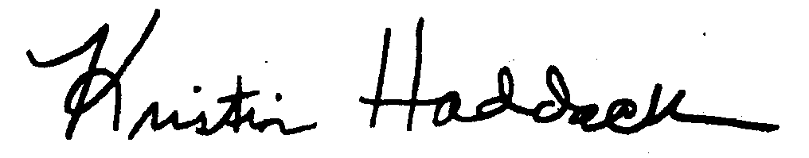
Kristin Haddock, Town Clerk

