Meeting Notice and Agenda
Town Board of Trustees
Regular Meeting
May 18, 2021 - 6:00 pm
Mounds Community Building
15 W 14th St, Mounds, OK 74047
1. Call to Order
2. Roll Call
3. Swearing in of new appointees
4. Mayor Selection
Discuss, consider and take possible action on appointing a Mayor
5. Vice-Mayor selection
Discuss, consider and take possible action on appointing a Vice-Mayor
6. Consent Agenda (A-I)
All matters listed under the “Consent “are considered by the Town Trustees to be routine and will be enacted by one motion. Any Trustee, however, can remove an item from the Consent Agenda by request.
A. Approval of the minutes of the April 13, 2021 Regular Board Meeting, May 3rd Special Meeting, May 10, Special Meeting
B. Approval of the Library report.
C. Approval of the Police report
D. Approval of the Fire report
E. Approval of the Financial report.
F. Approval of the Budget report.
G. Approval of the Court report.
H. Approval of the Purchase Orders for General Government, Fire Department and Court Fund.
I. Approval of the Purchase Orders for Streets & Alleys and Parks Depts.
7. Building Inspector Report
Discuss, consider, and take possible action on Building Inspector
8. Appoint Trustees to Departments
Discuss, consider and take possible action on assigning departmental duties
9. American Heritage Bank
Discuss, consider and take possible action on removing Robert Ford from signature cards on all American Heritage Bank accounts and adding Keith Long to the signature cards and accounts
10. Juvenile Justice Budget
Discuss, consider, and take possible action on amending Juvenile Justice Budget to include $2992 in capital outlay for Vista Grant cost share
11. Court Budget
Discuss, consider and take possible action on amending court budget to reduce interest income and include OBN fees, collection fees, bank fees, court laptops, and court software fees
12. Signature Stamp
Discuss, consider and take possible action on allowing a “Rosa Jackson” signature stamp to be used for signing checks and purchase orders
13. 2015 Ford Explorer
Discuss, consider and take possible action on the purchase of a 2015 Ford Explorer from OHP for $7,800 for the PD
14. Re-inspection Fees
Discuss, consider and take possible action on re-inspection fees.
15. Event Chairperson
Discuss, consider and take possible action on Event Chairperson Proposal
16. Adjournment

This agenda was filed in the office of the Town Clerk and posted at _6__ pm on May 17, 2021, at the Mounds Municipal Building located at 1319 Commercial Ave, Mounds, OK 74047 and the Mounds Community Building located at 15 W 14th St, in Mounds, OK 74047, by Town Clerk Kristin Haddock.

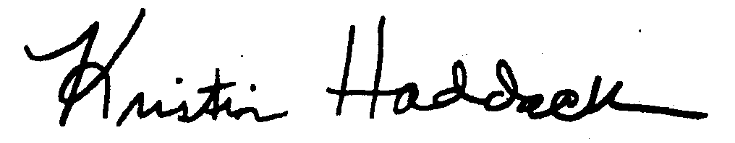
_______________________
Kristin Haddock Town Clerk

