MEETING NOTICE AND AGENDA

Town Board of Trustees
Special Town Budget Meeting
May 23, 2022 – 6:00 pm
Mounds Community Building
15 W 14th St, Mounds OK 74047

- Call to Order Time _________

- Roll Call
Culbert _____ Veale _____ Jackson _____ Long _____ Dossey _____

- Proposed Library Budget 2022-2023
Discuss, consider, and take possible action on 2022-2023 proposed Library Budget
Motion: _________________________ Second : _________________________
Culbert _____ Veale _____ Jackson _____ Long _____ Dossey _____

- Proposed Beautification/Demolition Budget 2022-2023

Discuss, consider, and take possible action on 2022-2023 proposed Beautification/ Demolition Budget
Motion: _________________________ Second : _________________________
Culbert _____ Veale _____ Jackson _____ Long _____ Dossey _____

- Proposed Public Works Budget 2022-2023

Discuss, consider, and take possible action on 2022-2023 proposed Public Works Budget
Motion: _________________________ Second : _________________________
Culbert _____ Veale _____ Jackson _____ Long _____ Dossey _____

- Proposed Streets & Alleys Budget 2022-2023

Discuss, consider, and take possible action on 2022-2023 proposed Streets & Alleys Budget
Motion: _________________________ Second : _________________________
Culbert _____ Veale _____ Jackson _____ Long _____ Dossey _____

- Proposed Street Repair Budget 2022-2023

Discuss, consider, and take possible action on 2022-2023 proposed Street Repair Budget
Motion: _________________________ Second : _________________________
Culbert _____ Veale _____ Jackson _____ Long _____ Dossey _____

- Proposed Parks Budget 2022-2023

Discuss, consider, and take possible action on 2022-2023 Parks Budget
Motion: _________________________ Second : _________________________
Culbert _____ Veale _____ Jackson _____ Long _____ Dossey _____
- Proposed Fire Department Budget 2022-2023

Discuss, consider, and take possible action on 2022-2023 proposed Fire Department Budget.
Motion: _________________________ Second : _________________________
Culbert _____ Veale _____ Jackson _____ Long _____ Dossey _____
- Proposed Court Budget 2022-2023

Discuss, consider, and take possible action on 2022-2023 proposed Court Budget
Motion: _________________________ Second : _________________________
Culbert _____ Veale _____ Jackson _____ Long _____ Dossey _____

- Proposed Juvenile Court Budget 2022-2023

Discuss, consider, and take possible action on proposed Juvenile Court Budget
Motion: _________________________ Second : _________________________
Culbert _____ Veale _____ Jackson _____ Long _____ Dossey _____
- Events Budget 2022-2023

Discuss, consider, and take possible action on 2022-2023 proposed Events Budget
Motion: _________________________ Second : _________________________
Culbert _____ Veale _____ Jackson _____ Long _____ Dossey _____
- Proposed Police Budget 2022-2023

Discuss, consider, and take possible action on 2022-2023 proposed Police Budget
Motion: _________________________ Second : _________________________
Culbert _____ Veale _____ Jackson _____ Long _____ Dossey _____

- Proposed Police Training and Equipment Budget 2022-2023
Discuss, consider, and take possible action on 2022-2023 proposed Police Training and Equipment Budget.
Motion: _________________________ Second : _________________________
Culbert _____ Veale _____ Jackson _____ Long _____ Dossey _____

- Proposed Police Reserve Budget 2022-2023

Discuss, consider, and take possible action on proposed Police Reserve Budget
Motion: _________________________ Second : _________________________
Culbert _____ Veale _____ Jackson _____ Long _____ Dossey _____
- Proposed General Fund Budget 2022-2023

.
33Discuss, consider, and take possible action on proposed General Fund Budget for 2022-2023
Motion: _________________________ Second : _________________________
Culbert _____ Veale _____ Jackson _____ Long _____ Dossey _____

17. Adjournment Time ______________

This agenda was filed in the office of the Town Clerk and posted at 6 pm on May 18, 2022, at the Mounds Municipal Building located at 1319 Commercial Ave, Mounds, OK 74047 and the Mounds Community Building located at 15 W 14th St, in Mounds, OK 74047

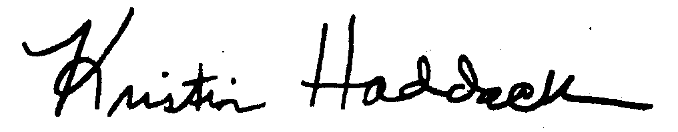
______________________________
Kristin Haddock Town Clerk

