Notice of Public Hearing

A Public Hearing has been set for Tuesday, September 13, 2016 at 6 PM, at the Mounds Community Building at 15 West 14th Street in Mounds to be held in conjunction with the regularly scheduled Town Board of trustees Meeting. The purpose of the hearing is to receive comments and recommendations on the structure located at 110 East 15th Street, Mounds, OK, abated property. These comments and recommendations will be considered by the Board of Trustees. Citizens are requested to participate in the hearing to express their views on this property. The Town of Mounds Board of Trustees will incorporate any comments or proposals, where feasible.
Posted this 9th day of September 2016 at the following locations:
- Mounds Municipal Offices
- Mounds Community Building
Anyone requiring special accommodations pursuant to the American with Disabilities Act should notify Kristin Haddock, Town Clerk at (918) 224-5624 or call the Mounds Municipal Offices at (918) 827-6711

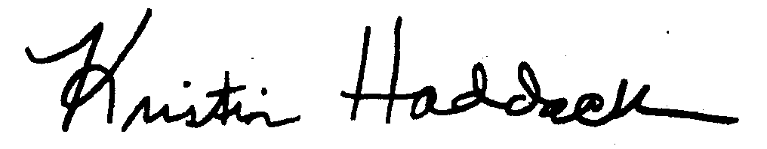

By: _______________________________
Kristin Haddock
Town Clerk

