Meeting Notice and Agenda
Town Board of Trustees
Regular Meeting
November 1, 2022 – 6:00 pm
Mounds Community Building
15 W 14th Street, Mounds OK 74047

1. Call to Order Time: _____________

2. Roll Call

Culbert _____ Veale _____ Jackson _____ Long _____ Dossey _____

3. Consent Agenda (A-K)
All matters listed under “Consent” are considered by the Town Board to be routine and will be enacted by one motion. Any Trustee, however, can remove an item from the Consent Agenda by request.

A. Approval of the Minutes for the October 1, 2022, Regular Board Meeting, Special Meeting October 18, 2022
B. Approval of the Library report
C. Approval of the Police report
D. Approval of the Fire report
E. Approval of the Financial report
F. Approval of the Budget report
G. Approval of the Court report
I. Approval of Purchase Orders for Streets & Alleys and Parks Departments
J. Building Inspector Report
K. Mayor’s Report
L. Approval of the Purchase Orders for General Government, Fire Department, and Court Fund

Motion: _________________________ Second: _________________________
Culbert _____ Veale _____ Jackson _____ Long _____ Dossey _____

4. Remodel Price
Discuss, consider, and take possible action on the price to remodel City Hall and the Police Station.
Motion: _________________________ Second: _________________________
Culbert _____ Veale _____ Jackson _____ Long _____ Dossey _____

5. Public Works Building
Discuss, consider, and take possible action on purchasing a building for Public Works.

Motion: _________________________ Second: _________________________
Culbert _____ Veale _____ Jackson _____ Long _____ Dossey _____

6. Fire Department Building
Discuss, consider, and take possible action on purchasing a building for the Fire Department.

Motion: _________________________ Second: _________________________
Culbert _____ Veale _____ Jackson _____ Long _____ Dossey _____

7. Digital Sign
Discuss, consider, and take possible action on purchasing a digital sign
Motion: _________________________ Second: _________________________
Culbert _____ Veale _____ Jackson _____ Long _____ Dossey _____

8. Executive Session.

The Board may consider retiring into Executive session for the purpose of discussions concerning the appraisal or purchase of real property, in accordance with 25 O.S. Section 307(B)(3).

Motion: _________________________ Second: _________________________
Culbert _____ Veale _____ Jackson _____ Long _____ Dossey _____

9. Adjournment ____

This Agenda was filed in the office of the Town Clerk and posted at 6 PM on October 31, 2022, at the Mounds Municipal Building located at 1319 Commercial Avenue, Mounds, OK 74047 and the Mounds Community Building located at 15 W 14th Street in Mounds, OK 74047, by Town Clerk Kristin Haddock.

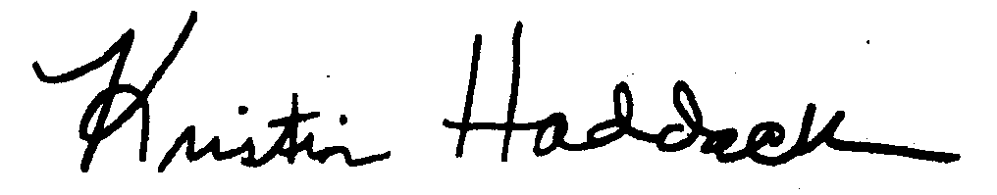
Kristin Haddock, Town Clerk

