Meeting Notice and Agenda
Town Board of Trustees
Regular Meeting
October 11, 2022 – 6:00 pm
Mounds Community Building
15 W 14th Street, Mounds OK 74047

1. Call to Order

2. Roll Call

3. Consent Agenda (A-K)
All matters listed under “Consent” are considered by the Town Board to be routine and will be enacted by one motion. Any Trustee, however, can remove an item from the Consent Agenda by request.

A. Approval of the Minutes for the September 13, 2022, Regular Board Meeting, Special Meeting September 6, 2022
B. Approval of the Library report
C. Approval of the Police report
D. Approval of the Fire report
E. Approval of the Financial report
F. Approval of the Budget report
G. Approval of the Court report
I. Approval of Purchase Orders for Streets & Alleys and Parks Departments
J. Building Inspector Report
K. Mayor’s Report
L. Approval of the Purchase Orders for General Government, Fire Department, and Court Fund

4. One-time Pay Increase
Discuss, consider, and take possible action on a one-time pay increase

5. Matt Ingham Lot Split
Discuss, consider, and take possible action on Matt Ingham Lot Split

6. Parkhill Master Service
Discuss, consider, and take possible action on Parkhill Master Service Agreement for Creek County ARPA Grant

7. Digital Sign
Discuss, consider, and take possible action on purchasing a digital sign

8. Surplus
Discuss, consider, and take possible action on surplus Kaiser

9. Curfew
Discuss, consider, and take possible action on curfew times

10. Bad debt write off
Discuss, consider, and take possible action on bad debt write-off on acct #677 in the amount of $52.00, Fire Department
11. Adjournment

This Agenda was filed in the office of the Town Clerk and posted at 6 PM on October 10, 2022, at the Mounds Municipal Building located at 1319 Commercial Avenue, Mounds, OK 74047 and the Mounds Community Building located at 15 W 14th Street in Mounds, OK 74047, by Town Clerk Kristin Haddock.

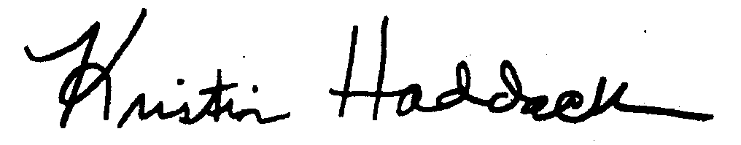
Kristin Haddock, Town Clerk

