Meeting Notice and Agenda
Town Board of Trustees
Regular Meeting
October 17, 2023 – 6:30 pm
Mounds Community Building
15 W 14th Street, Mounds OK 74047

1. Call to Order

2. Roll Call

3. Consent Agenda (A-K)
All matters listed under “Consent” are considered by the Town Board to be routine and will be enacted by one motion. Any Trustee, however, can remove an item from the Consent Agenda by request.

A. Approval of the Minutes for the September 19, 2023, regular meeting and September 27, 2023 Special Meeting.
B. Approval of the Library report
C. Approval of the Police report
D. Approval of the Fire report
E. Approval of the Financial report
F. Approval of the Budget report
G. Approval of the Court report
H. Approval of Purchase Orders for Streets & Alleys and Parks Departments
I. Building Inspector Report
J. Approval of the Purchase Orders for General Government, Streets & Alleys, and
Court Fund

4. Purchase approval
Discuss, consider, and take possible action on approving a digital sign purchase.

5. Inspector Contract
Discuss, consider, and take possible action on contract for building inspector.

6. CCRWD #7
Discuss, consider, and take possible action on proposed CCRWD #7 contract.

7. HVAC Unit
Discuss, consider, and take possible action on replacing HVAC unit for the Community Center.

8. Sidewalk Café 75
Discuss, consider, and take possible action on sidewalk repair in conjunction with ODOT in front of Café 75.

9. Events Committee
Discuss, consider, and take possible action on Trunk or Treat and Christmas Festivities plans.

10. 2024 Calendar
Discuss, consider, and take possible action on 2024 Meeting, Court, and Holiday Calendars.

11. Gilcrease-Vowell Cemetery
Discuss, consider, and take possible action on Gilcrease-Vowell Cemetery.

12. November Meeting
Discuss, consider, and take possible action on rescheduling November’s meeting due to general election.

13. 2022 REAP Contract Extension
Discuss, consider, and take possible action on extending the 2022 REAP contract Extension (widening 17th street).

14. Executive Session
The Trustees will consider retiring into Executive Session for the purpose of discussion for item A. related to the employment, hiring, appointment, promotion, demotion of individual salaried (Police Department) making permanent for benefit purposes in accordance with O.S. Title 25, Section 307(B)(1).

- Trustees will consider and take any action deemed appropriate to Police Department

15. Adjournment

This Agenda was filed in the office of the Town Clerk and posted at 6 PM on October 16, 2023, at the Mounds Municipal Building located at 1319 Commercial Avenue, Mounds, OK 74047 and the Mounds Community Building located at 15 W 14th Street in Mounds, OK 74047, by Town Clerk Kristin Haddock.

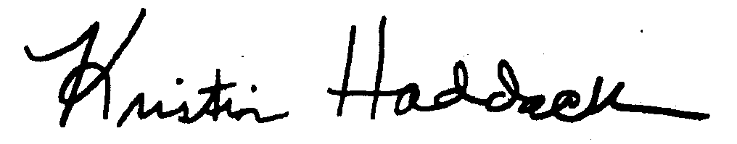
Kristin Haddock, Town Clerk

