Meeting Notice and Agenda
Town Board of Trustees
Regular meeting
September 13, 2016 – 6:00 pm
Mounds Community Building
15 W 14th St, Mounds, OK 74047

1. Call to Order Time __________
2. Roll Call
Veale ___ Jackson, D ___ Reynolds ___ Ingham ___ Jackson, R ___
3. Invocation
4. Pledge of Allegiance
5. Consent Agenda (A-I)
All matters listed under the “Consent “are considered by the Town Board to be routine and will be enacted by one motion. Any Trustee may, however, remove an item from the Consent Agenda by request.
A. Approval of the minutes of the August 9, 2016 Regular Board Meeting
B. Approval of the Library report.
C. Approval of the Police report
D. Approval of the Fire report
E. Approval of the Financial report.
F. Approval of the Budget report.
G. Approval of the Court report.
H. Approval of the Purchase Orders for General Government, Fire Department and Court Fund.
I. Approval of the Purchase Orders for Streets & Alleys and Parks Depts.
K. Approval of the minutes from August 29, 2016 Special Town Board meeting.
Motion ___________________________ Second __________________
Roll call: Veale ___ Jackson, D ___ Reynolds ___ Ingham ___ Jackson, R ___
6. Public Hearing
Discuss, consider and take possible action on opening Public Hearing.
PUBLIC HEARING to determine if a structure located at 110 E. 15th St, Mounds, OK, has become dilapidated and has become detrimental to the health, safety or welfare of the general public and the community or a fire hazard, and possible action related to abatement of the condition of the property.
Motion ___________________________ Second __________________
Roll call: Veale ___ Jackson, D ___ Reynolds ___ Ingham ___ Jackson, R ___
7. Adjourn Public Hearing Time: ______
8. Structure located at 110 E. 15th Street, Mounds, OK
Discuss, consider and take possible action relating to whether a structure located at 110 East 15th Street, Mounds, OK has become dilapidated and has become detrimental to the health, safety or welfare of the general public and the community or a fire hazard, and recommend appropriate action related to abatement of the condition of the property.
Motion ___________________________ Second __________________
Roll call: Veale ___ Jackson, D ___ Reynolds ___ Ingham ___ Jackson, R ___
9. Building Inspector Report
10. 2008 Dodge Charger Bids
Discuss, consider and take possible action on the Police Department’s 2008 Dodge Charger Bid
Motion ___________________________ Second __________________
Roll call: Veale ___ Jackson, D ___ Reynolds ___ Ingham ___ Jackson, R ___
11. Russell St from 16th-17th
Discuss, consider and take possible action on closing off Russell St from 16th-17th for the school.
Motion ___________________________ Second __________________
Roll call: Veale ___ Jackson, D ___ Reynolds ___ Ingham ___ Jackson, R ___
12. Police Budget Amendment
Discuss, consider and take possible action on Police Department Budget amendments.
Motion ___________________________ Second __________________
Roll call: Veale ___ Jackson, D ___ Reynolds ___ Ingham ___ Jackson, R ___
13. City Treasurer
Discuss, consider and take possible action on establishing a policy to have Treasurer attend court proceedings to issue receipts, collect payments and assist Court Clerk regarding fines, or a Trustee in the event the Treasurer is not available or is unable to attend.
Motion ___________________________ Second __________________
Roll call: Veale ___ Jackson, D ___ Reynolds ___ Ingham ___ Jackson, R ___
14. Town Permits
Discuss, consider and take possible action on Town Permits.
Motion ___________________________ Second __________________
Roll call: Veale ___ Jackson, D ___ Reynolds ___ Ingham ___ Jackson, R ___
15. City Hall and Police Station
Discuss, consider and take possible action on construction of a new City Hall and Police Station and/or relocation of City Hall and Police Station to new location.
Motion ___________________________ Second __________________
Roll call: Veale ___ Jackson, D ___ Reynolds ___ Ingham ___ Jackson, R ___
16. Review of Probationary Period
Discuss and consider review of probationary period, and expiration thereof, for employees Judi Brown and Jeannie Sexton and/or take possible action deemed necessary regarding the probationary period.
Motion ___________________________ Second __________________
Roll call: Veale ___ Jackson, D ___ Reynolds ___ Ingham ___ Jackson, R ___
17. Medical Director
Discuss, consider and take possible action on Medical Director for Fire Department
Motion ___________________________ Second __________________
Roll call: Veale ___ Jackson, D ___ Reynolds ___ Ingham ___ Jackson, R ___
18. Executive Session
The Board will consider retiring into Executive Session for the purpose of discussion related to the employment, hiring, appointment, promotion, demotion, disciplining or resignation of individual salaried public officer or employees (Police Chief) in accordance with O.S. Title 25, Section 307(B)(1):
Motion _____________________ Second _______________________
Roll call: Veale ___ Jackson, D ___ Reynolds ___ Ingham ___ Jackson, R ___
- Council will consider returning to the Regular Meeting following the Executive Session. Time _______
- Board will consider and take any action deemed appropriate, as a result of the Executive Session.

Motion _____________________ Second _______________________
19. Adjournment Time _______________
This agenda was filed in the office of the Town Clerk and posted at _6__ pm on September 12, 2016 at the Mounds Municipal Building located at 1319 Commercial Ave, Mounds, OK 74047 and the Mounds Community Building located at 15 W 14th St, in Mounds, OK 74047, by Town Clerk Kristin Haddock.
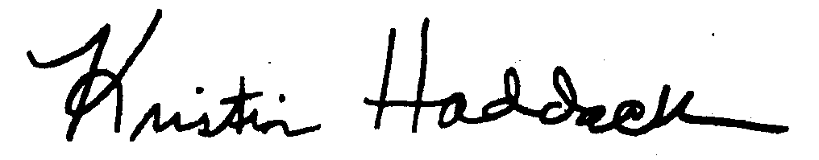
______________________________
Kristin Haddock Town Clerk

