Meeting Notice and Agenda
Town Board of Trustees
Regular Meeting
September 13, 2022 – 6:00 pm
Mounds Community Building
15 W 14th Street, Mounds OK 74047

1. Call to Order Time: _____________

2. Roll Call

Culbert _____ Veale _____ Jackson _____ Long _____ Dossey _____

3. Consent Agenda (A-K)
All matters listed under “Consent” are considered by the Town Board to be routine and will be enacted by one motion. Any Trustee, however, can remove an item from the Consent Agenda by request.

A. Approval of the Minutes for the August 9, 2022, Regular Board Meeting, Special Meeting September 5, 2022
B. Approval of the Library report
C. Approval of the Police report
D. Approval of the Fire report
E. Approval of the Financial report
F. Approval of the Budget report
G. Approval of the Court report
I. Approval of Purchase Orders for Streets & Alleys and Parks Departments
J. Building Inspector Report
K. Mayor’s Report
L. Approval of the Purchase Orders for General Government, Fire Department, and Court Fund

Motion: _________________________ Second: _________________________
Culbert _____ Veale _____ Jackson _____ Long _____ Dossey _____

4. Barbara’s Resignation
Discuss, consider, and take possible action on Barbara’s resignation

Motion: _________________________ Second: _________________________
Culbert _____ Veale _____ Jackson _____ Long _____ Dossey _____

5. REAP Grant
Discuss, consider, and take possible action on selecting project(s) for the INCOG REAP grant(s)

Motion: _________________________ Second: _________________________
Culbert _____ Veale _____ Jackson _____ Long _____ Dossey _____

6. Resolution 20220913
Discuss, consider, and take possible action on Resolution 20220913, authorizing application for the INCOG REAP Grant

Motion: _________________________ Second: _________________________
Culbert _____ Veale _____ Jackson _____ Long _____ Dossey _____

7. 2021-2022 Budget amendments
Discuss, consider, and take possible action on 2021-2022 budget amendments

Motion: _________________________ Second: _________________________
Culbert _____ Veale _____ Jackson _____ Long _____ Dossey _____

8. June 30, 2022, Financials
Discuss, consider, and take possible action on June 30, 2022, financials

Motion: _________________________ Second: _________________________
Culbert _____ Veale _____ Jackson _____ Long _____ Dossey _____

9. Main Street Trick or Treat
Discuss, consider, and take possible action on Main Street Trick or Treat

Motion: _________________________ Second: _________________________
Culbert _____ Veale _____ Jackson _____ Long _____ Dossey _____

10. Curfew
Discuss, consider, and take possible action on a curfew

Motion: _________________________ Second: _________________________
Culbert _____ Veale _____ Jackson _____ Long _____ Dossey _____

11. Adjournment

This Agenda was filed in the office of the Town Clerk and posted at 6 PM on September 12, 2022, at the Mounds Municipal Building located at 1319 Commercial Avenue, Mounds, OK 74047 and the Mounds Community Building located at 15 W 14th Street in Mounds, OK 74047, by Town Clerk Kristin Haddock.

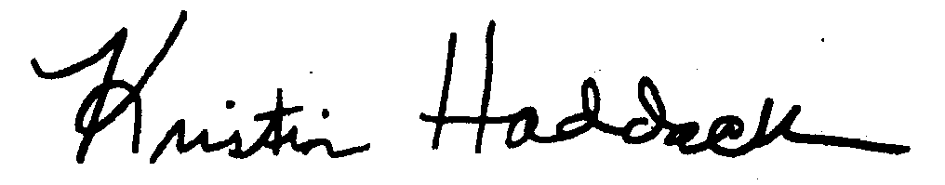
Kristin Haddock, Town Clerk

